

DVTK Design Specification
Validation Library

Version 1.0
2005-06-29
Table of Contents
1 Introduction 8
1.1 Purpose 8
1.2 Scope 8
1.3 Audience 8
1.4 Abbreviations and acronyms 8
1.5 References 8
1.6 History 8
2 Validation concepts 10
2.1 Validation Steps 10
2.2 The Global Overview 11
2.2.1 Building the results structure 11
2.2.2 Condition check for including a module 13
3 Detail design of validation component 14
3.1 Class Description of Validation Engine 14
3.1.1 Setting the user options 14
3.1.2 Setting the strict validation options 14
3.1.3 Setting the Type3 attribute option 15
3.1.4 Validating the ACSE & DIMSE messages 15
3.1.5 Selecting the validator 15
3.1.6 Setting the last requested dataset 16
3.2 Class Description of Validator 16
3.2.1 DefBuildModuleResults 17
3.2.2 DefBuildAttributeGroupResults 17
3.2.3 DefBuildSQResults 17
3.2.4 DefBuildMacroResults 18
3.2.5 DefBuildAttributeResults 18
3.2.6 DefBuildValueResults 19
3.2.7 BuildModuleResults 19
3.2.8 BuildAttributeGroupResults 19
3.2.9 BuildSQResults 19
3.2.10 BuildValueResults 20
3.2.11 Getting the result type 20
3.2.12 Validating the results 20
3.2.13 Creating the result object 20
3.3 Description of Validation Attribute Group classes 21
3.3.1 Attribute group class 22
3.3.1.1 Managing the parent result object 22
3.3.1.2 Setting/Getting the attribute group type 23
3.3.1.3 Managing the validation attribute in the attribute group 23
3.3.1.4 Validate the object against the definition 23
3.3.1.5 Validate the attribute VR 23
3.3.1.6 Validate the object against the reference 24
3.3.2 Attribute class 25
3.3.2.1 Managing the parent attribute group object 25
3.3.2.2 Setting/Getting the attribute type 26
3.3.2.3 Managing the validation attribute values for an attribute 26
3.3.2.4 Validate the DICOM attribute against the definition attribute 26
3.3.2.5 Validate the attribute VR 26
3.3.2.6 Validate the DICOM attribute against the reference attribute 27
3.3.2.7 Managing the validation attribute values for an attribute 27
3.3.2.8 Helper functions for checking attribute VR, VM & values 27
3.3.3 Base value class 29
3.3.3.1 Setting the parent attribute object 29
3.3.3.2 Setting/Getting the attribute values 29
3.3.3.3 Checking the validity of values for an DICOM attribute 29
3.3.3.4 Comparing the values of an DICOM & Reference attribute 30
3.3.4 Value SQ class 31
3.3.4.1 Adding the validation item 31
3.3.4.2 Getting the index validation item 31
3.3.4.3 Getting the nr. Of items 31
3.3.4.4 Checking the validity of values for an DICOM attribute 31
3.3.4.5 Validate the validation item against the definition attribute 32
3.3.4.6 Validate the validation item against the reference attribute 32
3.4 Class Description of Validation object results 33
3.4.1 Managing the module result 33
3.4.2 Managing the validation attribute & attribute group from object results 34
3.4.3 Validate the object against the definition 34
3.4.4 Validate the attribute VR 34
3.4.5 Validate the object against the reference 35
3.5 Pseudo code describing the flow of Validation 36
3.5.1 Definition results 36
3.5.2 Referenced file results 37
3.5.3 Incoming data 37
3.5.4 Keeping references 37
3.5.5 Validation using the results structure 37
4 ACSE Validation 38
4.1 Abort Request Validation 38
4.1.1 Getting the source parameter 38
4.1.2 Getting the reason parameter 38
4.1.3 Validating the Abort request 38
4.1.4 ACSE_AB_SOURCE_CLASS 39
4.1.4.1 Checking the syntax of source parameter 39
4.1.4.2 Checking the range of source parameter 39
4.1.4.3 Checking the source parameter against reference value 39
4.1.5 ACSE_AB_REASON_CLASS 39
4.1.5.1 Checking the syntax of reason parameter 39
4.1.5.2 Checking the range of reason parameter 39
4.1.5.3 Checking the reason parameter against reference value 39
4.2 Association Request Validation 40
4.2.1 Getting the protocol version parameter 40
4.2.2 Getting the called AE title parameter 40
4.2.3 Getting the calling AE title parameter 40
4.2.4 Getting the Application context name parameter 40
4.2.5 Getting the nr of Presentation contexts 40
4.2.6 Getting the Presentation context parameter 40
4.2.7 Getting the User information parameter 41
4.2.8 Validating the Association request 41
4.2.9 Checking all presentation contexts 41
4.2.10 Updating the presentation context 41
4.2.11 Checking the uniqueness of Presentation context ids 41
4.2.12 Checking the uniqueness of SOP classes in presentation context ids 41
4.3 Association Accept Validation 42
4.3.1 Getting the protocol version parameter 42
4.3.2 Getting the called AE title parameter 42
4.3.3 Getting the calling AE title parameter 42
4.3.4 Getting the Application context name parameter 42
4.3.5 Getting the nr of Presentation contexts 42
4.3.6 Getting the Presentation context parameter 43
4.3.7 Getting the User information parameter 43
4.3.8 Validating the Association request 43
4.3.9 Checking all presentation contexts 43
4.3.10 Updating the presentation context 43
4.3.11 Checking the uniqueness of Presentation context ids 43
4.3.12 Checking the uniqueness of SOP classes in presentation context ids 43
4.4 Association Reject Validation 44
4.4.1 Getting the source parameter 44
4.4.2 Getting the reason parameter 44
4.4.3 Getting the result parameter 44
4.4.4 Validating the Association reject request 44
4.4.5 ACSE_RJ_SOURCE_CLASS 44
4.4.5.1 Checking the syntax of source parameter 45
4.4.5.2 Checking the range of source parameter 45
4.4.5.3 Checking the source parameter against reference value 45
4.4.6 ACSE_RJ_REASON_CLASS 45
4.4.6.1 Checking the syntax of reason parameter 45
4.4.6.2 Checking the range of reason parameter 45
4.4.6.3 Checking the reason parameter against reference value 45
4.4.7 ACSE_RJ_RESULT_CLASS 46
4.4.7.1 Checking the syntax of result parameter 46
4.4.7.2 Checking the range of result parameter 46
4.4.7.3 Checking the result parameter against reference value 46
4.5 ACSE Parameter class 47
4.5.1 Setting the name of the association parameter 47
4.5.2 Setting /Getting the value of the association parameter 47
4.5.3 Getting the meaning of the association parameter 47
4.5.4 Managing the messages 47
4.5.5 Validate the association parameter syntax, range 48
4.5.6 Helper functions for checking the syntax and references 48
4.5.7 ACSE_AE_TITLE_CLASS 48
4.5.7.1 Checking the syntax of AE title parameter 48
4.5.7.2 Checking the range of AE title parameter 48
4.5.7.3 Checking the AE title parameter against reference value 48
4.5.8 ACSE_APPL_CTX_NAME_CLASS 48
4.5.8.1 Checking the range of Application context name parameter 48
4.5.9 ACSE_PROTOCOL_VERSION_CLASS 49
4.5.9.1 Checking the syntax of Protocol version parameter 49
4.5.9.2 Checking the range of Protocol version parameter 49
4.5.9.3 Checking the Protocol version parameter against reference value 49
4.6 ACSE Async Operation Windows Validator Class 49
4.6.1 Getting the Operations Invoked parameter 49
4.6.2 Getting the Operations performed parameter 49
4.6.3 Validating the Asynchronous Operations Window 49
4.6.4 ACSE_OPERATION_CLASS 50
4.6.4.1 Checking the syntax of operation parameter 50
4.6.4.2 Checking the range of operation parameter 50
4.6.4.3 Checking the operation parameter against reference value 50
4.7 ACSE Presentation Context Request Validator Class 51
4.7.1 Getting the Presentation Context Id parameter 51
4.7.2 Getting the Abstract Syntax name parameter 52
4.7.3 Getting the Transfer Syntax name parameter 52
4.7.4 Getting the Presentation Context Id 52
4.7.5 Getting the Abstract Syntax name 52
4.7.6 Getting the nr of Transfer Syntax 52
4.7.7 Getting the Transfer Syntax name 52
4.7.8 Checking the Presentation Context uniqueness 52
4.7.9 Checking the Transfer Syntaxes 52
4.7.10 Validating the requested Presentation Context 52
4.7.11 ACSE_UID_CLASS 53
4.7.11.1 Checking the syntax of UID parameter 53
4.7.11.2 Checking the range of UID parameter 53
4.7.11.3 Checking the UID parameter against reference value 53
4.7.11.4 Checking the UID syntax 53
4.8 ACSE Presentation Context Acceptor Validator Class 54
4.8.1 Getting the Presentation Context Id parameter 54
4.8.2 Getting the Abstract Syntax name parameter 54
4.8.3 Getting the Result parameter 54
4.8.4 Getting the Transfer Syntax name parameter 54
4.8.5 Getting the Presentation Context Id 54
4.8.6 Getting the Abstract Syntax name 54
4.8.7 Getting the result of Presentation Context request 54
4.8.8 Getting the Transfer Syntax name 55
4.8.9 Checking the Presentation Context uniqueness 55
4.8.10 Validating the accepted Presentation Context 55
4.9 ACSE User Information Validator Class 56
4.9.1 ACSE_SCP_SCU_ROLE_SELECT_VALIDATOR_CLASS 56
4.9.2 Getting the UID parameter 56
4.9.3 Getting the SCP role parameter 57
4.9.4 Getting the SCU role parameter 57
4.9.5 Validating the SCP/SCU role selection parameter 57
4.9.6 ACSE_SOP_CLASS_EXTENDED_VALIDATOR_CLASS 57
4.9.7 Getting the UID parameter 57
4.9.8 Getting the number of Application Information 57
4.9.9 Getting the Application Information 57
4.9.10 Validating the SOP Class Extended parameter 57
4.9.11 ACSE_IMPLEMENTATION_VERSION_NAME_CLASS 57
4.9.11.1 Checking the syntax of Protocol version parameter 58
4.9.11.2 Checking the range of Protocol version parameter 58
4.9.11.3 Checking the Protocol version parameter against reference value 58
4.9.12 ACSE_MAXIMUM_LENGTH_RECEIVED_CLASS 58
4.9.12.1 Checking the syntax of Maximum Length parameter 58
4.9.12.2 Checking the range of Maximum Length parameter 58
4.9.12.3 Checking the Maximum Length parameter against reference value 58
5 Media validation 59
5.1 Description of Media Validation classes 60
5.1.1 DefBuildFMIResults 60
5.1.2 DefBuildMediaResults 61
5.1.3 DefBuildDicomDirResults 61
5.1.4 BuildRecordResults 61
5.1.5 Validating the File Dataset 62
5.1.6 Validating the DICOMDIR 62
5.1.7 Validating the Record 62
5.1.8 Validating the reference file 63
5.1.9 Validating the record references 64
5.1.10 Copying of the object results 64
5.1.11 Serializing the validation results 64
5.1.12 Getting the directory record 64
5.1.13 Checking the directory record links 64
5.1.14 Getting the record link by offset 64
5.1.15 Checking the Directory record chain 64
5.1.16 Checking the vertical (down) & Horizontal record links 64
5.1.17 Comparing the record UIDs with referenced file 65
5.1.18 Comparing the record attributes with referenced file 65
5.2 Record Results Class 66
5.2.1 Validating the directory record 66
5.2.2 Checking the Maximum Length parameter against reference value 66
5.2.3 Validating the reference file linked with a record 66
5.2.4 Building the persistent information about record UIDs 67
5.2.5 Getting the referenced file name 67
5.2.6 Getting the record index 67
5.2.7 Getting the record type 67
5.2.8 Extracting the UIDs 67
5.2.9 Checking for the un-referenced records 67
5.2.10 Checking for the retired records 67
5.2.11 Checking for the reference file existence on the media 67
5.3 Record UID Class 68
5.3.1 Installation of all defining instance UID/identifier 68
5.3.2 Installation of all referring instance UID/identifier 68
5.3.3 Checking the log messages 68
5.3.4 Storing of all referring instance UID/identifier 68
5.3.5 UID Ref Class 69
5.3.5.1 Getting/Setting the UID of reference object 69
5.3.5.2 Adding a new defining entity to the UID reference object 69
5.3.5.3 Adding a new referring entity to the UID reference object 69
5.3.5.4 Checking the log messages 69
5.4 Record Link Class 69
5.4.1 Getting/Setting the down link offset 69
5.4.2 Getting/Setting the horizontal link offset 69
5.4.3 Getting the record offset 70
5.4.4 Getting/Setting the in-use flag for a record 70
5.4.5 Managing the reference count for a record 70
5.4.6 Getting/Setting the record type 70
5.4.7 Checking the Un-referenced record 70
5.5 Record Type Class 71
5.5.1 Getting the record type from record name 71
5.5.2 Getting the record type index 71
5.5.3 Getting lower list of record type with the given index 72
5.5.4 Getting record type name with the given index 72
5.5.5 Getting the record identifying tags 72
5.5.6 Checking if record is retired 72
5.5.7 Checking the child record status 72
5.5.8 Creating the all supported record types 72
5.5.9 Creating the one record type 72
6 Query/Retrieve Validation 73
6.1 QR Validator Class 73
6.1.1 Validate the build results object 73
6.1.2 Create the results object 73
6.1.3 Build the results object with requested dataset 73
6.2 QR Object Results Class 74
6.2.1 Checking if record is retired 74
6.3 Validation QR Attribute Class 74
6.3.1 Setting the requested attribute 74
6.3.2 Getting the requested attribute 74
6.3.3 Checking against the requested attribute 74

Introduction

Purpose
This document describes the DICOM Validation concepts and global and detail design of the validation component. This is a living document and changes in the design should be laid down in this document. Especially the sections on detailed design Definition classes may change during the project.

Scope
The Validation component does validation by rigorously checking the type and content of objects generated for the supported SOP Classes by DICOM conforming devices. This library defines classes used to describe the main data structure used by the DICOM Validation Tool.

Audience
This document is intended for all the implementers in the DVT project. The reader is assumed to have basic DICOM knowledge.

Abbreviations and acronyms
Abbreviation / acronym | Description
AE | Application Entity
Definition File | File containing the DICOM SOP Class description(s).
DVT | DICOM Validation Tool.
Session File | File containing the test session parameters.
User | Person who is implementing the Definition library.
IOD | Information Object Definition
VM | Value Multiplicity
VR | Value Representation
DICOM Media File | A File with a content formatted according to the requirements of DICOM Standard Part10. These files shall contain, the File Meta Information and a properly formatted Data Set.
DICOMDIR File | A unique and mandatory DICOM File within a File-set which contains the Media Storage Directory SOP Class. This File is given a single component File ID, DICOMDIR.

References
Reference | Title | Author/Publisher | Document number
VALIDATION |  | M. van Minderhout | XZS 980-000190.00
DESIGNSPEC |  | R. Busbridge  M. van Minderhout | XZS 980-000183.01
PATTERNS | Design Patterns | E. Gamma et al. | ISBN 0201633612
DCM | DICOM standard 2004 | NEMA | PS 3.0-2004
DEFINITION | Definition File Specification | M. van Minderhout | XZS 980-000123.00

History
Version | Date | Author | Description
0.1 | 18 May 2005 | Piyush Bhageriya  Manisha Singla | Initial version
1.0 | 29 June 2005 | Piyush Bhageriya  Manisha Singla | Update for OpenSource release

Validation concepts
The test concept is based on the facts that test scenarios can be written, which under specified conditions, define the expected type and content of objects generated by these DICOM devices. Validation is then achieved by comparing the reference (expected) object with the actual object generated by the device (System Under Test). In case no reference object is available, validation can also be achieved by checking the actual objects against the DICOM definition, provided via the definition files [DEFINITION].

Validation Steps
Two distinct parts of the DICOM validation can be identified as:
- Validation of Association Negotiation Control Service Elements (ACSE’s) - Association Request, Acceptance, Rejection, Release and Abort support.
- Validation of DICOM Message Exchange - Service Object Pair Class support.
In practice, it may not always be possible to know in advance, what the content of the actual object returned from the Tested System is going to be, particularly with the DICOM Message Exchange. Therefore, validation will be done in two steps:

STEP1
Validate the received object conforms to the Tested System’s Definition (provided via definition files [DEFINITION]. This ensures that the correct parameters/attributes are present in the object and that they are encoded correctly.
For each attribute the following properties are validated:
- Is the attribute expected according to the DICOM standard and/or the reference object, possibly depending on a condition
- Value Representation (VR):
- Value Multiplicity (VM)
- Values: Defined/enumerated terms

STEP2
This step is optional and only applied if a reference object is available. In this step reference objects with particular attributes defined are compared. The values of the parameters/attributes must match those of the reference object. Checks made here are that the expected number of attribute values has been received and that each attribute value matches the corresponding reference object attribute value.
Normally, reference objects validation will apply to the DIMSE objects only.
If the value of attributes is known in advance for objects used in the DICOM Message Exchange, STEP 2 Validation is applicable; otherwise STEP 1 Validation will be sufficient.

The Global Overview

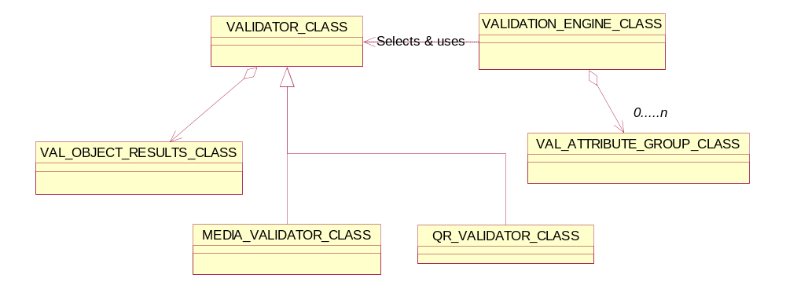
Figure 1 Classes relationship diagram for validation component

The figure above shows the main interface class and the relation to the real validator class. There is a need of dedicated validation algorithms for media validation, ACSE, standard validation and the Query/Retrieve validation. The main entry point for starting the validation is the validation engine class. Depending on the incoming data, the correct validator is selected by the validation engine. The next step would be to create a result structure containing the necessary information to perform validation. When the results structure has been built, the actual validation can begin.

Building the results structure
When validation is about to start, a results structure will be created. Part of this results structure is the (part of) contents of a definition object. This definition object is a service class and a SOP class. This object contains all possible attributes that can be expected in an incoming DICOM message.
A definition object contains one or more so-called modules. Each of these modules can be mandatory, conditional or user optional. When a module is mandatory, there’s no difficult check to do; the attributes in that module need to be available in the incoming DICOM message. When a module is conditional or user optional, a check on the incoming DICOM message needs to be done whether this module is indeed expected. Therefore, to build an initial results structure, the definition object and the DICOM message needs to be known.
Within a definition object, one or more macros can be defined. A macro is a group of one or more attributes that can be included per definition or condition. When the object results structure is generated, macros will be expanded. The results structure will keep a reference to the original macro for possible use when generating error messages.
Conditions can be in a definition object on modules, macros and attributes. When generating the object result structure, the conditions for modules and macros will be evaluated and depending on the result, the object result structure will be updated. For attributes, the attribute is always copied (actually a reference to the attribute is made) to the object result structure. When validating the DICOM object against the definition object, the conditions for attributes are evaluated. To be very flexible in the condition checking, an attribute may need to know some values of the parent object. Therefore each attribute group needs to keep a reference – if applicable – to its parent object.
If a reference object is available in the warehouse, the attributes of that object are added to the object results structure. The final step in filling the object results structure is to add the attributes from the DICOM data stream.
Now that all modules and all attributes are known in the object results structure, the values for each attribute need to be set. A definition attribute can have a list of defined terms, enumerated values or both. The DICOM data needs to be validated against such a list. There is no restriction on the order of receiving each value for such a list (validation algorithms later on may prove to have some errors here
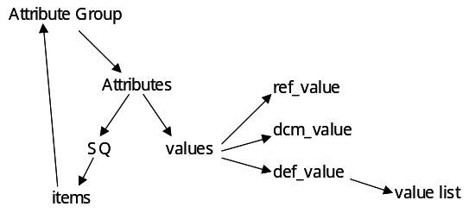
Figure 2

Figure 3 Attribute structure in validation component

though).

The picture above displays the linking structure between the various data elements needed for validation. The attribute group maintains a list of attributes. Each attribute maintains a list of values. A specific case is the SQ type of attribute. In that case, the value of the attribute maintains a list of items that is in fact a single attribute group per item.
Setting the references to the reference value, DICOM value and the definition value, is the last step in filling the object results structure. The definition value may be a list of defined terms or enumerated values, so that’s the reason why it’s being linked to a value list.
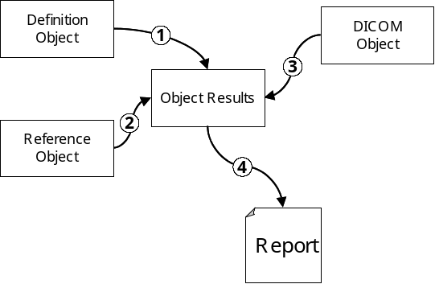
Figure 4

The picture above displays the process needed to validate a DICOM object. When the object results structure is filled, the actual validation of the object can be done. All problems – if any – are added to the object results structure. These problems are then the input for the final report that can be generated.

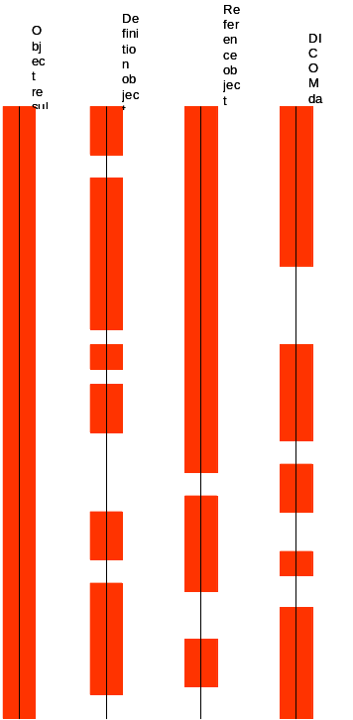

The picture above gives an impression how the data in the object results structure contains the information from the three data streams. The object results structure contains all data from all three sources. Each of the three sources is a subset of the object results structure.

Condition check for including a module
The various modules in the definition files contain a set of attributes. Each module will have some attributes that are unique with respect to other modules – such an attribute is only available in one module. When a module is encountered that needs a condition to be evaluated (both user optional and conditional), the attributes of the module will be added to the object results when at least one unique attribute has been encountered.

Detail design of validation component

Class Description of Validation Engine
Validation engine is a singleton class and provides a single access point to validation component. The validation engine controls the validation process. It provides different types of validation functions and instantiates the correct validation algorithm.
Before a validation can take place two things must be determined:
- What kind of validation must be performed (depending on the object to be validated and the context it is in)
- What definition(s) must be used?

To determine these things some control logic is required and this control logic is located in the validation engine. The validation engine provides a set of overloaded validation functions. Depending on the parameters the validation engine determines what definition(s) to use and what validator to instantiate. This class also controls the validation options, which may be set via the command line or graphical user-interface(s).
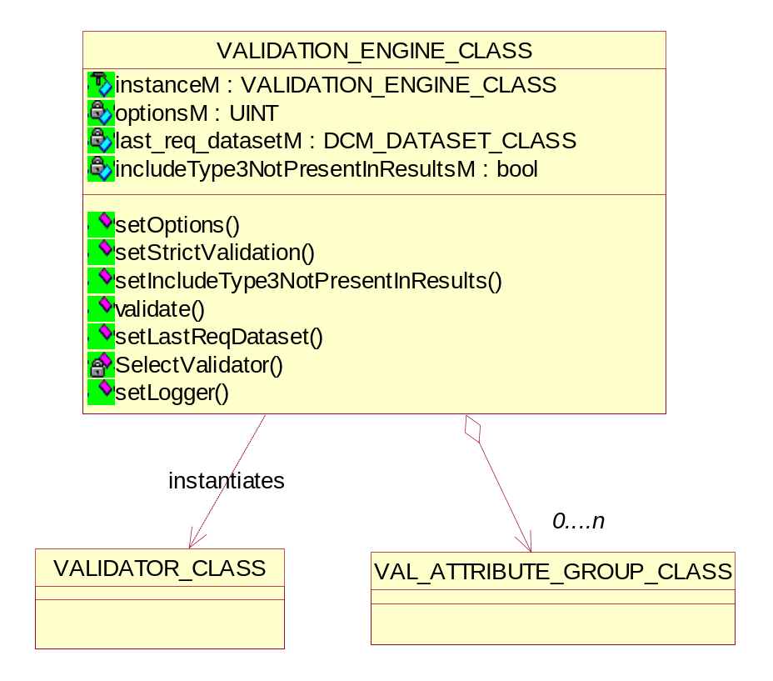
Figure 2 Validation Engine class diagram

Setting the user options
void setOptions(UINT options);
This function sets the validation options provided in the DVT GUI.

Setting the strict validation options
Validation can be set to be strict or non-strict. The differences are as follows:
Strict validation
The presence of attributes must match the definitions exactly.
Non-strict validation
- Private attributes are allowed to be present
- Any group length attribute is allowed to be present
void setStrictValidation (bool);
This function sets the strict validation option provided to the user.

Setting the Type3 attribute option
This option, when enabled, is used to have DVT include all Type 3 attributes in the detailed results even if these attributes are not present in the dataset being validated. When this property is disabled, the detailed results produced contain only the attributes present in the dataset being validated.
void setIncludeType3NotPresentInResults(bool);
This function enables/disables the Type3 attribute option provided to the user.

Validating the ACSE & DIMSE messages

1. bool validate(ABORT_RQ_CLASS*, ABORT_RQ_CLASS*, VALIDATION_CONTROL_FLAG_ENUM, BASE_SERIALIZER*);
2. bool validate(ASSOCIATE_RQ_CLASS*,ASSOCIATE_RQ_CLASS*,
VALIDATION_CONTROL_FLAG_ENUM, BASE_SERIALIZER*,
ACSE_PROPERTIES_CLASS*);
3. bool validate (ASSOCIATE_AC_CLASS*,ASSOCIATE_AC_CLASS*,
VALIDATION_CONTROL_FLAG_ENUM, BASE_SERIALIZER*,
ACSE_PROPERTIES_CLASS*);
4. bool validate (ASSOCIATE_RJ_CLASS*,ASSOCIATE_RJ_CLASS*,
VALIDATION_CONTROL_FLAG_ENUM, BASE_SERIALIZER*);
5. bool validate (RELEASE_RQ_CLASS*, RELEASE_RQ_CLASS*,
VALIDATION_CONTROL_FLAG_ENUM, BASE_SERIALIZER*);
6. bool validate(RELEASE_RP_CLASS*, RELEASE_RP_CLASS*,
VALIDATION_CONTROL_FLAG_ENUM, BASE_SERIALIZER*);
7. bool validate (UNKNOWN_PDU_CLASS*,UNKNOWN_PDU_CLASS*,
VALIDATION_CONTROL_FLAG_ENUM, BASE_SERIALIZER*);
8. bool validate (DCM_COMMAND_CLASS*,DCM_COMMAND_CLASS*, VALIDATION_CONTROL_FLAG_ENUM, BASE_SERIALIZER*);
9. bool validate (DCM_DATASET_CLASS*,DCM_DATASET_CLASS*,
DCM_COMMAND_CLASS*, VALIDATION_CONTROL_FLAG_ENUM,
BASE_SERIALIZER*, AE_SESSION_CLASS*);
10.bool validate(FILE_DATASET_CLASS*,DCM_DATASET_CLASS*,
VALIDATION_CONTROL_FLAG_ENUM, BASE_SERIALIZER*,
AE_SESSION_CLASS*);
11.bool validate(DCM_DATASET_CLASS*,DCM_DATASET_CLASS*,
VALIDATION_CONTROL_FLAG_ENUM, BASE_SERIALIZER*,
AE_SESSION_CLASS*);
The different overloads are available for validating ACSE & DIMSE messages.
- The overloads 1 to 6 are used to validate ACSE objects.
- The overload 7 is used for unknown PDU object validation.
- The overloads 8 and 9 are used to validate DIMSE dataset & command set objects.
- The overload 10 is used for media dataset object validation.
- The overload 11 is used for dataset validation without command e.g. record validation.

Selecting the validator
VALIDATOR_CLASS* SelectValidator(DCM_COMMAND_CLASS* cmd_ptr,
DCM_DATASET_CLASS* dataset_ptr);
This function instantiates and selects the correct validator.

Setting the last requested dataset
void setLastReqDataset(DCM_DATASET_CLASS*);
This function sets the last requested dataset.

Class Description of Validator
The validator takes care of the actual validation. The validator class implements the template algorithm for validation. The template algorithm provides hook operation for derived classes to override.

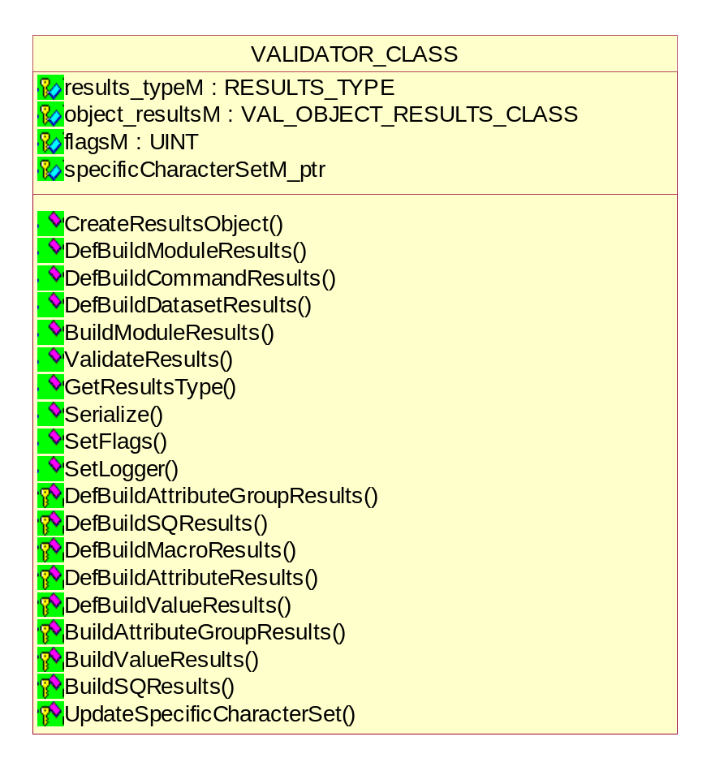
Figure 3 Validator class diagram

Currently the following validators are implemented for DIMSE objects:
- The Standard Validator class
This is the default validator and does nothing special with respect to the template
- The QR Validator class
This validator takes care of special issues regarding Query/Retrieve validation
- The WLM Validator class
This validator takes care of special issues regarding Worklist management validation
- The Media validator class
This validator takes care of special issues regarding Media management validation
- The ACSE objects validators

The following methods described the flow of building definition object result.

DefBuildModuleResults
void DefBuildModuleResults(DEF_DICOM_OBJECT_CLASS* def_attr_grp,
DCM_ATTRIBUTE_GROUP_CLASS* dcm_attr_grp);

Argument | Explanation
def_attr_grp | A pointer to the module in the definition object
dcm_attr_grp | A pointer to the attribute group in the incoming DICOM data stream.
This function loops through all the modules in the definition object. For each module a check is done to see if the module needs to be added to the results object. The check depends on the condition associated with the module. There are three possibilities: Mandatory, User or Conditional. If the result of the check is positive, a new ModuleResults object will be created. This object will contain the module specific information such as name, usage and condition information. The attributes for the module will be added in the DefBuildAttributeGroupResults function.

DefBuildAttributeGroupResults
void DefBuildAttributeGroupResults(
DEF_ATTRIBUTE_GROUP_CLASS * def_attr_grp,
DCM_ATTRIBUTE_GROUP_CLASS * dcm_attr_grp,
VAL_ATTRIBUTE_GROUP_CLASS * val_obj_results,
bool useTextualCondition);

Argument | Explanation
def_attr_grp | A pointer to the module in the definition object
dcm_attr_grp | A pointer to the attribute group in the incoming DICOM data stream
val_obj_results | A pointer to an attribute group results object that will be filled with the attributes needed for the validation process
useTextualCondition | A boolean indicates the use of textual condition
This function will fill the given object results structure with expected attributes. This depends on the definition object and the DICOM data.
From the definition object, each attribute will simply be added to the object results structure. No condition checking is done. Special attention must be given to the SQ value representation. When a SQ attribute is encountered in the definition object, this is copied to the object results. A SQ attribute contains zero or more items. Each item is a specialized attribute group. When a SQ attribute is encountered, the attribute is copied to the object results, then the function DefBuildSQResults is called.
When a macro is encountered in the definition attribute group, the function DefBuildMacroResults is called.

DefBuildSQResults
In the definition object, a SQ attribute has been encountered that needs to be added to the object results. The SQ attribute in the definition object defines exactly one item. That item contains one or more attributes. In the DICOM data object, zero or more items can be encountered.
void DefBuildSQResults (VALUE_SQ_CLASS * def_attr,
DCM_VALUE_SQ_CLASS * dcm_attr,
VAL_VALUE_SQ_CLASS * val_sq_results,
bool useTextualCondition);

Argument | Explanation
def_attr | A reference to the SQ attribute in the definition object.
dcm_attr | A reference to the SQ attribute in the DICOM object.
val_sq_results | A pointer to a SQ attribute results object that will be filled with the items needed for the validation of the complete sequence found in the DICOM SQ attribute.
useTextualCondition | A boolean indicates the use of textual condition
This function adds the number of items in the DICOM data object to the object results. The content of each item is dependent on the content of the definition object.
Since an item is a specialized attribute group, the function DefBuildAttributeGroupResults is called to fill exactly one item.

DefBuildMacroResults
void DefBuildMacroResults (DEF_MACRO_CLASS * def_attr_grp,
DCM_ATTRIBUTE_GROUP_CLASS * dcm_attr_grp,
VAL_ATTRIBUTE_GROUP_CLASS * val_obj_results,
bool useTextualCondition);

Argument | Explanation
def_attr_grp | A reference to the module in the definition object
dcm_attr_grp | A reference to the attribute group in the incoming DICOM data stream
val_obj_results | A pointer to an attribute group results object that will be filled with the attributes needed for the validation process
useTextualCondition | A boolean indicates the use of textual condition
A macro contains one or more attributes that need to be added to an existing object results structure. The object results structure can already contain other attributes.
The content of the macro is copied to the object results structure. If a SQ attribute is encountered, the function DefBuildSQResults is called.
If another macro is included, the function DefBuildMacroResults is called recursively. This depends on a possible condition check for the macro.

DefBuildAttributeResults
void DefBuildAttributeResults(
DEF_ATTRIBUTE_CLASS * def_attr,
DCM_ATTRIBUTE_GROUP_CLASS * dcm_attr_grp,
VAL_ATTRIBUTE_CLASS * val_attr,
bool useTextualCondition);

Argument | Explanation
def_attr | A pointer to an attribute in the definition object
dcm_attr_grp | A pointer to the attribute group in the incoming DICOM data stream
val_attr | A pointer to an attribute in the validation object
useTextualCondition | A boolean indicates the use of textual condition
This function will build the definition attribute results.

DefBuildValueResults
void DefBuildValueResults(DEF_ATTRIBUTE_CLASS * def_attr, VAL_ATTRIBUTE_CLASS * val_attr);

Argument | Explanation
def_attr | A pointer to an attribute in the definition object
val_attr | A pointer to an attribute in the validation object
This function will build the definition values of an attribute results.

The following methods described the flow of building DICOM object result.

BuildModuleResults
void BuildModuleResults(DCM_ATTRIBUTE_GROUP_CLASS* dcm_attr_grp
bool dcm_results);

Argument | Explanation
dcm_attr_grp | A pointer to the attribute group in the incoming DICOM data stream.
dcm_results | A boolean decides the object is reference object or DICOM.
This function loops through all the modules in the incoming DICOM data stream. The loop sets the DICOM attribute group to all modules that have not yet been assigned a DICOM attribute group and that have the same attributes in the def attribute group.

BuildAttributeGroupResults
void BuildAttributeGroupResults(
DCM_ATTRIBUTE_GROUP_CLASS * dcm_attr_grp,
VAL_ATTRIBUTE_GROUP_CLASS * val_obj_results,
bool dcm_results);

Argument | Explanation
dcm_attr_grp | A pointer to the attribute group in the incoming DICOM data stream
val_obj_results | A pointer to an attribute group results object that will be filled with the attributes needed for the validation process
dcm_results | A boolean decides the object is reference object or DICOM.
This function will fill the given object results structure with the incoming attributes. Special attention must be given to the SQ value representation. When a SQ attribute is encountered in the definition object, this is copied to the object results. A SQ attribute contains zero or more items. Each item is a specialized attribute group. When a SQ attribute is encountered, the attribute is copied to the object results, then the function BuildSQResults is called.

BuildSQResults
In the DICOM object, a SQ attribute has been encountered that needs to be added to the object results. The SQ attribute in the definition object defines exactly one item. That item contains one or more attributes. In the DICOM data object, zero or more items can be encountered.
void BuildSQResults (DCM_ATTRIBUTE_CLASS * dcm_attr,
VAL_ATTRIBUTE_CLASS * val_attr,
bool dcm_results);

Argument | Explanation
dcm_attr | A reference to the SQ attribute in the DICOM object.
val_attr | A pointer to a SQ attribute results object that will be filled with the items needed for the validation of the complete sequence found in the DICOM SQ attribute.
dcm_results | A boolean decides the object is reference object or DICOM.
This function adds the number of items in the DICOM data object to the object results. The content of each item is dependent on the content of the DICOM object.
Since an item is a specialized attribute group, the function BuildAttributeGroupResults is called to fill exactly one item.

BuildValueResults
void BuildValueResults(DCM_ATTRIBUTE_CLASS * dcm_attr, VAL_ATTRIBUTE_CLASS * val_attr,
bool dcm_results);

Argument | Explanation
dcm_attr | A pointer to an attribute in the definition object
val_attr | A pointer to an attribute in the validation object
dcm_results | A boolean decides the object is reference object or DICOM.
This function will build the definition values of an attribute results.

Getting the result type
RESULTS_TYPE GetResultsType(void);
This function gets the result type.

Validating the results
virtual void ValidateResults(VALIDATION_CONTROL_FLAG_ENUM);
The selected validator will implement this function.

Creating the result object
virtual bool CreateResultsObject(void);
The method creates the results object.

Description of Validation Attribute Group classes
The class diagram shows the relationship between various Attribute Group classes for the Validation component.
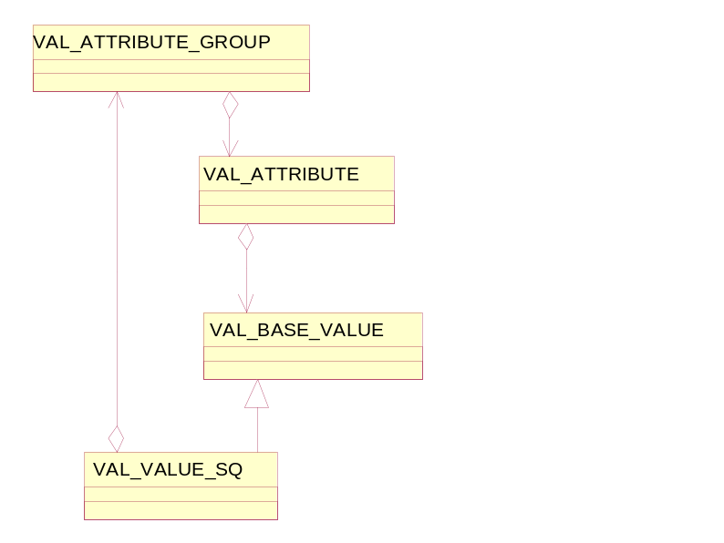
Figure 5

The above diagram shows the class diagram to be used for the object results structure. The classes in the diagram represent the items in the DICOM structure: Attribute group, attribute and value. Since the SQ value is special, it is derived from the base value class. At each level, messages can be stored in the log message class.

Attribute group class
The validation attribute group class maintains references to attribute groups coming from the definition, reference and the DICOM objects. This class keeps references to a list of attributes. The functions AddValAttribute, GetNrAttributes and GetAttribute are needed for accessing these attributes. Messages associated with the attribute group are stored in a message object.
This object can be retrieved with the GetMessages function. The message object does not know about the messages associated to its children.
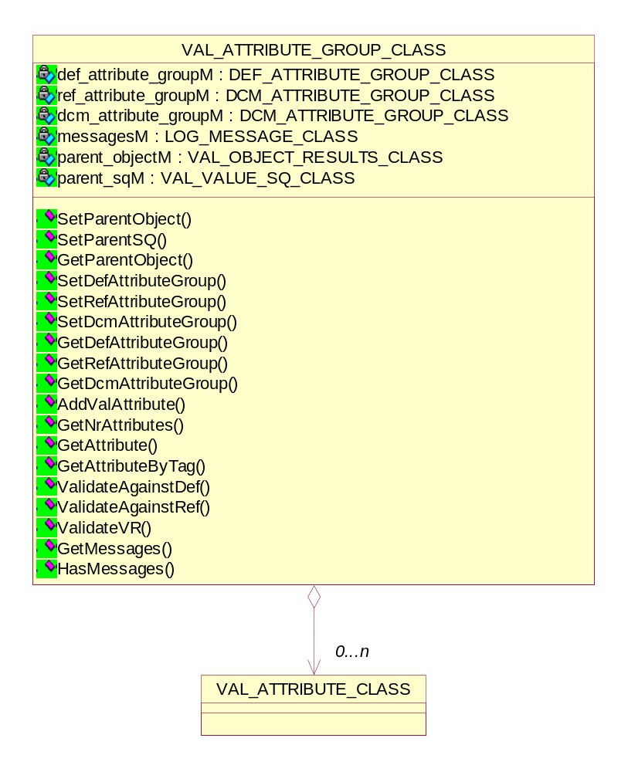
Figure 5 Diagram of Validation Attribute Group class

Managing the parent result object
- Get the parent result object
VAL_OBJECT_RESULTS_CLASS * GetParentObject(void);

- Set the parent result object
void SetParentObject(VAL_OBJECT_RESULTS_CLASS * parent);

- Set the parent result object for Sequence type
void SetParentSQ(VAL_VALUE_SQ_CLASS * parent);

Setting/Getting the attribute group type
These functions are needed in the attribute group class to set each type of attribute group.
- Setting the attribute group type
void SetDefAttributeGroup(DEF_ATTRIBUTE_GROUP_CLASS * def_ag);
void SetRefAttributeGroup(DCM_ATTRIBUTE_GROUP_CLASS * ref_ag);
void SetDcmAttributeGroup(DCM_ATTRIBUTE_GROUP_CLASS * dcm_ag);

- Getting the attribute group type
DEF_ATTRIBUTE_GROUP_CLASS * GetDefAttributeGroup(void);
DCM_ATTRIBUTE_GROUP_CLASS * GetRefAttributeGroup(void);
DCM_ATTRIBUTE_GROUP_CLASS * GetDcmAttributeGroup(void);

Managing the validation attribute in the attribute group
- Adding the attribute
bool AddValAttribute(VAL_ATTRIBUTE_CLASS * val_attr);

- Get the nr. Of attributes in the attribute group
int GetNrAttributes(void);

- Getting the attribute from the group, element or attribute tag
VAL_ATTRIBUTE_CLASS * GetAttribute(int attr_idx);
VAL_ATTRIBUTE_CLASS * GetAttribute(UINT16 group, UINT16 element);
VAL_ATTRIBUTE_CLASS * GetAttributeByTag(UINT32 tag);

Validate the object against the definition
DVT_STATUS ValidateAgainstDef(UINT32 flags);

Return value | Explanation
MSG_OK | Validating against the definition object has been successful. The object may contain faults though.
MSG_ERROR | An error has occurred when validating against the definition object.
This function loops through all the attributes in a module. Each attribute in a module is checked against the values in the definition object and validation options provided in the flags.

Validate the attribute VR
DVT_STATUS ValidateVR( UINT32 flags,
SPECIFIC_CHARACTER_SET_CLASS *specificCharacterSet_ptr);

Return value | Explanation
MSG_OK | Checking VR compliance has been successful. The object may contain faults though.
MSG_ERROR | An error has occurred when checking the VR compliance.
This function loops through all the attributes in a module. Each attribute in a module is checked for validity of the VR and validation options provided in the flags.

Validate the object against the reference
DVT_STATUS ValidateAgainstRef(UINT32 flags);

Return value | Explanation
MSG_OK | Validating against the reference object has been successful. The object may contain faults though.
MSG_ERROR | An error has occurred when validating against the reference object.
When there’s a reference object in the warehouse of DVT, the DICOM data stream will be validated against the reference object. This function loops through all the attributes in a module and validates against the validation options provided in the flags.

Attribute class
The attribute class maintains references to the attributes coming from the definition, reference and DICOM objects. Three functions are needed in the attribute class to add each type of attribute. And another three functions are needed to get each type of attribute.
An attribute has zero or more values associated with it. These values can be accessed through the AddValValue, GetNrValues and GetValue functions.
Messages associated with the attribute are stored in a message object. This object can be retrieved with the GetMessages function. The message object does not know about the messages associated to its children.
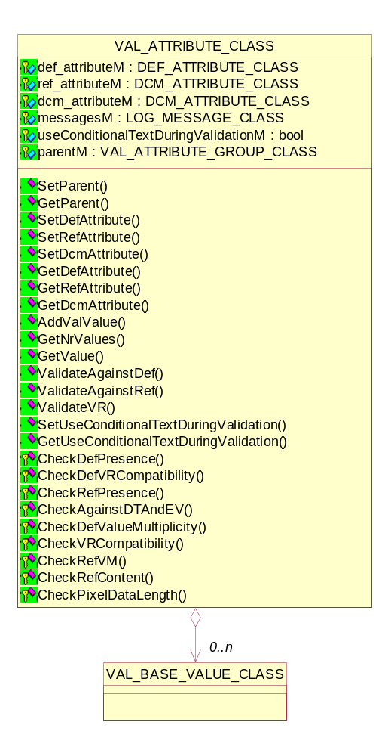
Figure 6 Diagram of Validation Attribute class

Managing the parent attribute group object
- Get the parent attribute group object
VAL_ATTRIBUTE_GROUP_CLASS * GetParentObject(void);

- Set the parent attribute group object
void SetParentObject(VAL_ATTRIBUTE_GROUP_CLASS * parent);

Setting/Getting the attribute type
These functions are needed in the attribute class to set each type of attribute.
- Setting the attribute type
void SetDefAttribute(DEF_ATTRIBUTE_CLASS * def_attr);
void SetRefAttribute(DCM_ATTRIBUTE_CLASS * ref_attr);
void SetDcmAttribute(DCM_ATTRIBUTE_CLASS * dcm_attr);

- Getting the attribute type
DEF_ATTRIBUTE_CLASS * GetDefAttributeGroup(void);
DCM_ATTRIBUTE_CLASS * GetRefAttributeGroup(void);
DCM_ATTRIBUTE_CLASS * GetDcmAttributeGroup(void);

Managing the validation attribute values for an attribute
- Adding the attribute value
bool AddValValue(VAL_BASE_VALUE_CLASS * val_attr);

- Get the nr. Of values of an attribute
int GetNrValues(void);

- Getting the index attribute value from the value list
VAL_BASE_VALUE_CLASS * GetValue(int value_idx=0);

Validate the DICOM attribute against the definition attribute
DVT_STATUS ValidateAgainstDef(UINT32 flags);

Return value | Explanation
MSG_OK | Validating against the definition attribute has been successful.
MSG_ERROR | An error has occurred when validating against the definition attribute.
This function loops through all the values of an attribute. Each attribute is checked against the values in the definition object and validation options provided in the flags. Each attribute results structure, maintains a list of messages and the corresponding Id’s. If an inconsistency in the attribute and the definition attribute exists that is critical, a flag (the so-called ‘critical’ flag) for that attribute will be set so that no more checks are done on that attribute. An example of a critical error is when the VR of the attribute is different from the one in the definition attribute. This method calls some helper functions to check VR compatibility, Value multiplicity etc.

Validate the attribute VR
DVT_STATUS ValidateVR( UINT32 flags,
SPECIFIC_CHARACTER_SET_CLASS *specificCharacterSet_ptr);

Return value | Explanation
MSG_OK | Checking VR compliance has been successful.
MSG_ERROR | An error has occurred when checking the VR compliance.
This function loops through all the values of an attribute. Each attribute is checked for validity of the VR and validation options provided in the flags. This check is not performed on attributes that have the ‘critical’ flag set. This flag could have been set when validating against the definition object. Any inconsistency is logged in the attribute results structure. If an attribute contains a fault that is critical, the ‘critical’ flag for that attribute will be set.

Validate the DICOM attribute against the reference attribute
DVT_STATUS ValidateAgainstRef(UINT32 flags);

Return value | Explanation
MSG_OK | Validating against the reference attribute has been successful.
MSG_ERROR | An error has occurred when validating against the reference attribute.
When there’s a reference object in the warehouse of DVT, the DICOM data stream will be validated against the reference object. This function loops through all the values of an attribute and validates against the validation options provided in the flags. When the ‘critical’ flag is set for the attribute, no check is performed. Otherwise the attribute will be checked against the reference attribute. Any inconsistency is logged in the attribute results structure. If an attribute contains a fault that is critical, the ‘critical’ flag for that attribute will be set. This method calls some helper functions to check VR compatibility, Value multiplicity etc.

Managing the validation attribute values for an attribute
- Getting/Setting the textual condition during validation
void SetUseConditionalTextDuringValidation(bool value);
bool GetUseConditionalTextDuringValidation();

Helper functions for checking attribute VR, VM & values
DVT_STATUS CheckDefPresence(UINT32 flags);
DVT_STATUS CheckDefVRCompatibility(UINT32 flags);
DVT_STATUS CheckRefPresence(UINT32 flags);
DVT_STATUS CheckAgainstDTAndEV(UINT32 flags);
DVT_STATUS CheckDefValueMultiplicity(UINT32 flags);
DVT_STATUS CheckVRCompatibility(UINT32 flags);
DVT_STATUS CheckRefVM(UINT32 flags);
DVT_STATUS CheckRefContent(UINT32 flags);
DVT_STATUS CheckPixelDataLength();
- Check attribute presence in definition object
This method checks the presence of the DICOM attribute against the definition attribute.
- Check attribute VR compatibility against definition object
This method checks the compatibility between the definition VR and that of the DICOM attribute.
- Check attribute presence in reference object
This method checks the presence of the DICOM attribute against the reference attribute.
- Check attribute against definition attribute enumerated values or defined terms
This method checks the DICOM attribute against any definition attribute enumerated values or defined terms.
- Check attribute VM in definition object
This method checks the DICOM attribute value multiplicity against the definition attribute.
- Check DICOM & reference attribute VR compatibility
This method checks the VR compatibility of the DICOM attribute and the
Reference attribute.
- Check DICOM & reference attribute VM
This method checks the VM of the DICOM attribute and the reference attribute.
- Check DICOM & reference attribute values
This method checks the values of the DICOM attribute and the reference attribute.
- Check DICOM & reference attribute values
This method checks the pixel data length is consistent with the image dimensions as defined by the rows, columns and bits allocated attributes.
The dimensions should match the pixel data length if the image is uncompressed. If the image is compressed we assume that the pixel data length will be less than the dimensions.

Base value class
The value class maintains the references to the values coming from the reference and the DICOM object. In the definition object, it’s possible to have a list of values (defined terms or enumerated values), thus the value class will keep a reference to the value list in the definition object. Three functions are needed to set each type of value (or value list). Another three functions are needed the get each type of value (or value list).
The function Check will check the DICOM value for validity of the VR. Any inconsistency will be logged in the messages structure.
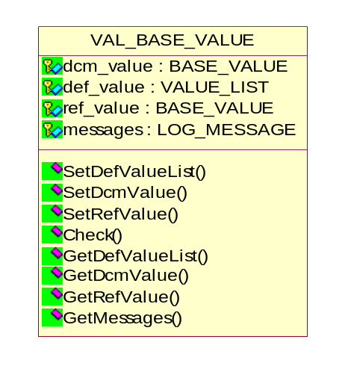
The message structure can be retrieved via the GetMessages function.

Figure 7 Diagram of Validation Base Value class

Setting the parent attribute object
void SetParent(VAL_ATTRIBUTE_CLASS * parent);

Setting/Getting the attribute values
These functions are needed in the attribute class to set each type of attribute value.
- Setting the attribute value
void SetDefValueList(VALUE_LIST_CLASS * def_value_list);
void SetRefValue (BASE_VALUE_CLASS * ref_value);
void SetDcmValue (BASE_VALUE_CLASS * dcm_value);

- Getting the attribute value
VALUE_LIST_CLASS * GetDefValueList (void);
BASE_VALUE_CLASS * GetRefValue (void);
BASE_VALUE_CLASS * GetDcmValue (void);

Checking the validity of values for an DICOM attribute
virtual DVT_STATUS Check(UINT32 flags,
SPECIFIC_CHARACTER_SET_CLASS *specificCharacterSet_ptr);
Return value | Explanation
MSG_OK | Validation of DICOM attribute values has been successful.
MSG_ERROR | An error has occurred when validating against the reference attribute.

Comparing the values of an DICOM & Reference attribute
DVT_STATUS CompareRef(void);
Return value | Explanation
MSG_EQUAL | The values of DICOM & reference attribute are equal.
MSG_NOT_EQUAL | The values are not equal.

Value SQ class
The sequence (SQ) VR is a special case for values. The values stored in a SQ class are zero or more items. Each item is an attribute group. The reference object and DICOM object may both contain zero or more items. This implies that a list of attribute groups will be maintained for these types of values. In most cases, each item in one sequence will contain the same attributes. The sequences in a DICOMDIR however are an exception. Therefore, the items coming from the definition object will also be stored in a list of attribute groups.
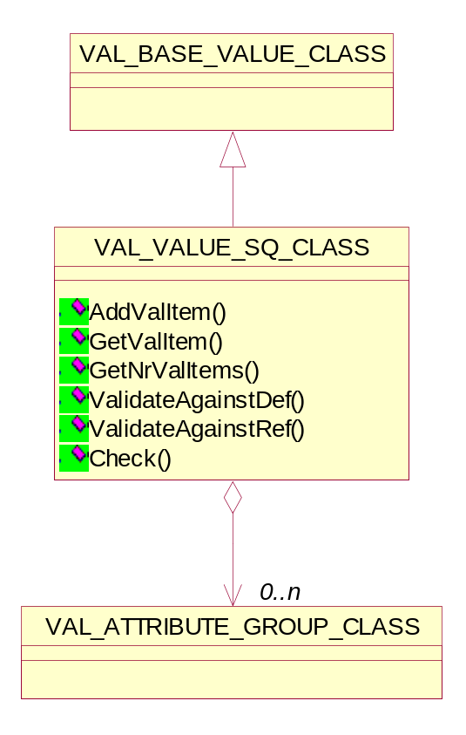
Figure 8 Diagram of Validation Value Sequence class

Adding the validation item
void AddValItem(VAL_ATTRIBUTE_GROUP_CLASS * val_item);

Getting the index validation item
VAL_ATTRIBUTE_GROUP_CLASS * GetValItem(int index);

Getting the nr. Of items
int GetNrValItems(void);

Checking the validity of values for an DICOM attribute
DVT_STATUS Check(UINT32 flags,
SPECIFIC_CHARACTER_SET_CLASS *specificCharacterSet_ptr);
Return value | Explanation
MSG_OK | Validation of Sequence attribute values has been successful.
MSG_ERROR | An error has occurred when validating against the definition sequence attribute.

Validate the validation item against the definition attribute
DVT_STATUS ValidateAgainstDef(UINT32 flags);

Return value | Explanation
MSG_OK | Validating against the definition attribute has been successful.
MSG_ERROR | An error has occurred when validating against the definition attribute.
This function loops through all the items. Each attribute is checked against the values in the definition object and validation options provided in the flags.

Validate the validation item against the reference attribute
DVT_STATUS ValidateAgainstRef(UINT32 flags);

Return value | Explanation
MSG_OK | Validating against the reference attribute has been successful.
MSG_ERROR | An error has occurred when validating against the reference attribute.
When there’s a reference object in the warehouse of DVT, the DICOM data stream will be validated against the reference object. This function loops through all the items and validates against the validation options provided in the flags.

Class Description of Validation object results
The object results structure contains the information from the three data streams i.e. definition object, Incoming DICOM object and expected reference object. It contains all data from all three sources. Each of the three sources is a subset of the object results structure.
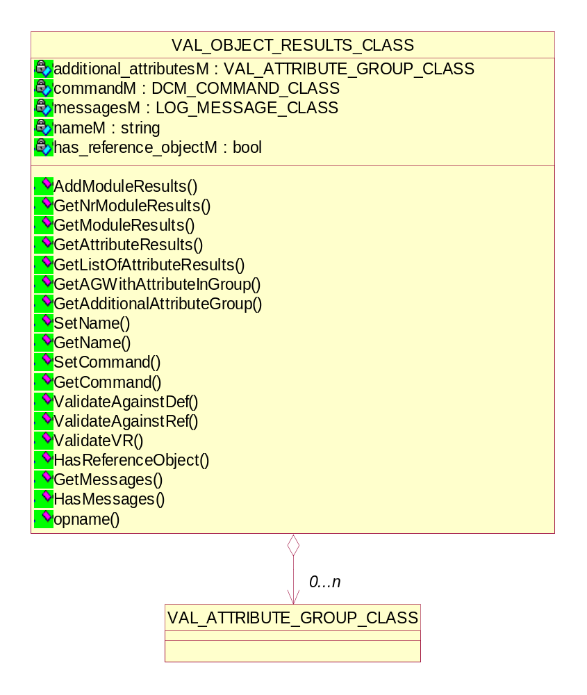
Figure 9 Diagram of Validation Object results class

Managing the module result
- Adding the module results to object results
DVT_STATUS AddModuleResults(VAL_ATTRIBUTE_GROUP_CLASS * mod_res);

- Adding the nr. Of module results to object results
int GetNrModuleResults(void);

- Getting the indexed module results from object results
VAL_ATTRIBUTE_GROUP_CLASS * GetModuleResults(int index);

Managing the validation attribute & attribute group from object results
- Getting the validation attribute
VAL_ATTRIBUTE_CLASS* GetAttributeResults(UINT16 group, UINT16 element);
VAL_ATTRIBUTE_CLASS *GetAttributeResults(UINT32 tag);
This function returns the validation attribute with the group and element or attribute tag specified. If the requested attribute is not found, NULL will be returned.
- Getting the attribute list
bool GetListOfAttributeResults(UINT16 group, UINT16 element, vector<VAL_ATTRIBUTE_CLASS *> * attr_list);
This function returns a list of validation attributes with the specified group and element. If the requested attribute is not found, 'false' will be the return value.

- Getting the validation attribute group from group nr.
VAL_ATTRIBUTE_GROUP_CLASS * GetAGWithAttributeInGroup(UINT16 group);
This function returns validation attribute group if the attribute group has an attribute in the requested group. If the attribute group is not found, NULL will be returned.

- Getting the additional attribute group
VAL_ATTRIBUTE_GROUP_CLASS * GetAdditionalAttributeGroup(void);

Validate the object against the definition
DVT_STATUS ValidateAgainstDef(UINT32 flags);

Return value | Explanation
MSG_OK | Validating against the definition object has been successful. The object may contain faults though.
MSG_ERROR | An error has occurred when validating against the definition object.
This function loops through all the modules in the object results structure. If an inconsistency in the attribute and the definition attribute exists that is critical, a flag (the so-called ‘critical’ flag) for that attribute will be set so that no more checks are done on that attribute. An example of a critical error is when the VR of the attribute is different from the one in the definition attribute.

Validate the attribute VR
DVT_STATUS ValidateVR( UINT32 flags,
SPECIFIC_CHARACTER_SET_CLASS *specificCharacterSet_ptr);

Return value | Explanation
MSG_OK | Checking VR compliance has been successful. The object may contain faults though.
MSG_ERROR | An error has occurred when checking the VR compliance.
This function loops through all the modules in the object results structure. Any inconsistency is logged in the attribute results structure. If an attribute contains a fault that is critical, the ‘critical’ flag for that attribute will be set.

Validate the object against the reference
DVT_STATUS ValidateAgainstRef(UINT32 flags);

Return value | Explanation
MSG_OK | Validating against the reference object has been successful. The object may contain faults though.
MSG_ERROR | An error has occurred when validating against the reference object.
When there’s a reference object in the warehouse of DVT, the DICOM data stream will be validated against the reference object. This function loops through all the modules in the object results structure. Any inconsistency is logged in the attribute results structure. If an attribute contains a fault that is critical, the ‘critical’ flag for that attribute will be set.

Pseudo code describing the flow of Validation
The validation algorithm used in DVT is based on building a results structure. This structure contains all the necessary information to eventually display validation information to the end user. The information is gathered from various sources.

Definition results
The definition files specify the groups, attributes, macros and other information that will eventually be expected in the incoming message. The first step in building the results structure is to examine the definition files. A definition object can contain multiple modules. Each module is a specialized attribute group. Since attribute groups can contain sequences containing zero or more items – which are in turn specialized attribute groups, examining attribute groups will be done recursively.

Loop over all modules in the definition object
If a module needs to be added (Conditional, User, Mandatory)
Create new validation module
Call the function to add an attribute group to the validation results

Below the process is described when an attribute group needs to be added:
Loop over all attributes in the module
Get the VR of that attribute
If VR==SQ
Create new SQ attribute validation object
Call the function to add an attribute group to the validation results (recursive)
Else
Create new attribute validation object
Copy the contents of the attribute to the new (SQ) attribute validation object
Set status -> source ODD
Add textual condition (if any)
In the attribute validation object, set the referenced source module
Loop over all macros in the module
If a macro needs to be added (through macro condition evaluation)
Call the function to add the macro results

Condition checking is done using the incoming data from the DICOM data stream (see paragraph 3.5.3). The only condition evaluated here, is the check if a module needs to be added. Condition checks on attributes are not evaluated. These attributes are added to the results structure. The condition is evaluated in a later stage of the validation process.

A macro can recursively include another macro. So this function needs to be implemented using recursion.
Loop over all attributes in the macro
If (Is the attribute already in the module?)
Update the properties of the attribute validation object
Else
Create new attribute validation object (may be SQ specific)
Copy all values from the attribute to the attribute validation object
Set status -> source ODD
In the attribute validation object, set the referenced source module
In the attribute validation object, set the referenced macro
Add textual condition (if any)
Loop over all macros in the macro
If a macro needs to be added (through macro condition evaluation)
Call the function to add the macro results (recursive)

It is possible that macros are recursively included. To prevent that DVT enters an endless loop, the incoming data stream must be used as input for conditionally including a macro. Condition checks on attributes are again not evaluated.
Sequences are considered to be special and will call the function to add an attribute group.

Referenced file results
If there’s a reference file, add the modules and the attributes to the results structure.
Loop over all attributes in the reference object
If the attribute is present already in the attribute validation results object
Update, if necessary, the VR of the attribute
Else
Create new attribute validation object (may be SQ specific)
Copy all values from the attribute to the attribute validation object
Set status -> source reference object

Incoming data
DICOM data that needs to be validated can come from various sources such as Media or Network. This data is simply referred to as DICOM data. The information needs to be added to the results structure.
Loop over all attributes in the DICOM data object
Get the tag of the attribute
If the attribute is present in the attribute validation results object
Set the DICOM reference attribute
Else
Create new attribute validation object (may be SQ specific)
Copy all values from the attribute to the attribute validation object
Set status -> DICOM object

Keeping references
To do a proper validation, the references to each source (definition, reference and incoming) object must be kept in the object. These objects must not be freed before the validation is completed.

Validation using the results structure
With the above data copied from the sources to the results structure, the results structure is now filled with the necessary information to perform the validation.
- Check against definition objects
This step loops through all attributes in the attribute results structure. The DICOM data is validated against the data imported from the definition files. Loop over all attributes in the results structure.
- Check against reference objects
This step loops through all attributes in the attribute results structure. The DICOM data is validated against the reference objects. Loop over all attributes in the results structure. This step is optional and only applied if a reference object is available.

ACSE Validation

Abort Request Validation
The ACSE A-ABORT service shall be used by a requestor in either of the AEs to cause the abnormal release of the association. It shall be a non-confirmed service. The abort shall be performed through A-ABORT request and A-ABORT indication primitives.
The class ABORT_RQ_VALIDATOR_CLASS validates the A-ABORT request and checks the source & reason parameter.

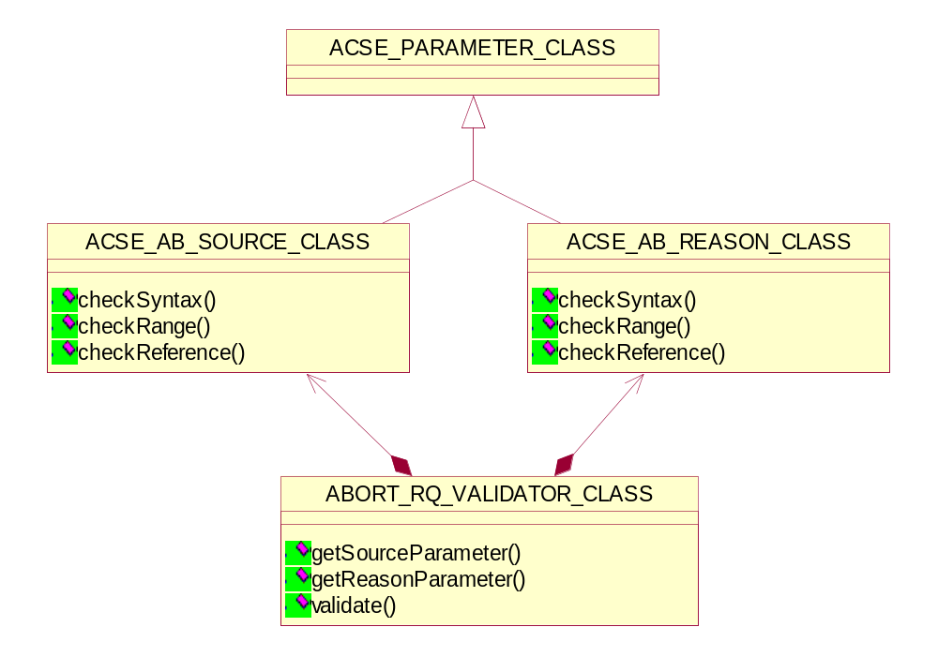
Figure 10 Diagram of Abort Requester Validator class

Getting the source parameter
ACSE_PARAMETER_CLASS *getSourceParameter();

Getting the reason parameter
ACSE_PARAMETER_CLASS *getReasonParameter();

Validating the Abort request
bool validate(ABORT_RQ_CLASS*, ABORT_RQ_CLASS*);
Return value | Explanation
true | Validation of the Abort request has been successful.
false | Validation of the Abort request has been failed.

ACSE_AB_SOURCE_CLASS
This class indicates the initiating source of this abort and derived from ACSE parameter class. This Source field shall contain an integer value encoded as an unsigned binary number.
One of the following values shall be used
0 - DICOM UL service-user (initiated abort
1 – reserved
2 - DICOM UL service-provider (initiated abort)

Checking the syntax of source parameter
bool checkSyntax();

Checking the range of source parameter
bool checkRange();
This method checks the range of source parameter value and the range should be in the fields defined above.

Checking the source parameter against reference value
bool checkReference(string);

ACSE_AB_REASON_CLASS
This class indicates the reason of this abort and derived from ACSE parameter class.
This field shall contain an integer value encoded as an unsigned binary number.
If the Source field has the value (2) “DICOM UL service-provider,” it shall take one of the following:
0 - reason-not-specified
1 - unrecognized-PDU
2 - unexpected-PDU
3 - reserved
4 - unrecognized-PDU parameter
5 - unexpected-PDU parameter
6 - invalid-PDU-parameter value
If the Source field has the value (0) “DICOM UL service-user,” reason field shall not be significant. It shall be sent with a value 00H but not tested to this value when received.

Checking the syntax of reason parameter
bool checkSyntax();

Checking the range of reason parameter
bool checkRange();
This method checks the range of reason parameter value and the range should be in the fields defined above.

Checking the reason parameter against reference value
bool checkReference(string);

Association Request Validation
The establishment of an association between two AEs shall be performed through ACSE A-ASSOCIATE request, indication, response and confirmation primitives.
The class ASSOCIATE_RQ_VALIDATOR_CLASS validates the A-ASSOCIATE request and checks all the association parameters.
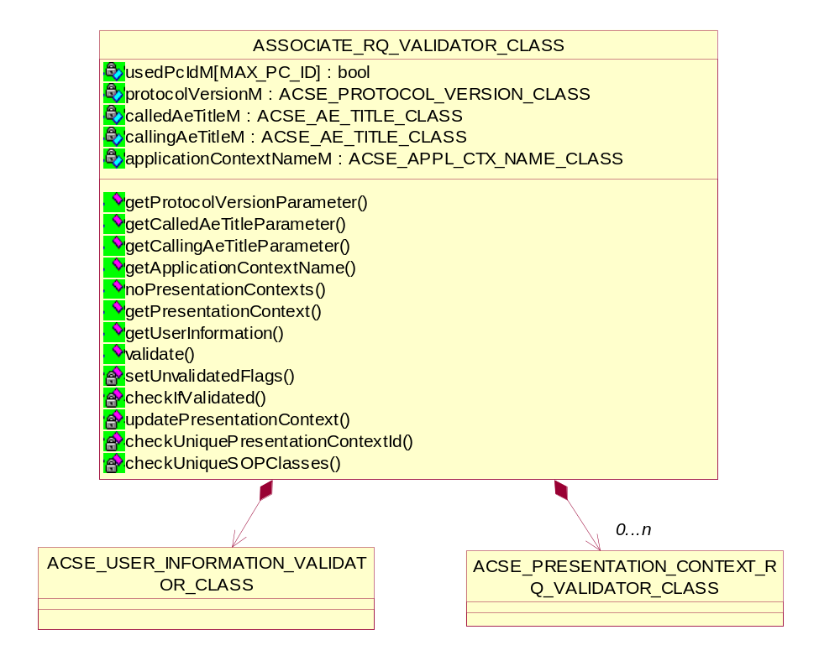
Figure 11 Diagram of Associate Requester Validator class

Getting the protocol version parameter
ACSE_PARAMETER_CLASS *getProtocolVersionParameter();

Getting the called AE title parameter
ACSE_PARAMETER_CLASS *getCalledAeTitleParameter();

Getting the calling AE title parameter
ACSE_PARAMETER_CLASS *getCallingAeTitleParameter();

Getting the Application context name parameter
ACSE_APPL_CTX_NAME_CLASS& getApplicationContextName();

Getting the nr of Presentation contexts
UINT noPresentationContexts();

Getting the Presentation context parameter
ACSE_PRESENTATION_CONTEXT_RQ_VALIDATOR_CLASS& getPresentationContext(UINT);

Getting the User information parameter
ACSE_USER_INFORMATION_VALIDATOR_CLASS& getUserInformation();

Validating the Association request
bool validate(ASSOCIATE_RQ_CLASS *srcAssocRq_ptr,
ASSOCIATE_RQ_CLASS *refAssocRq_ptr,
ACSE_PROPERTIES_CLASS * acseProp_ptr);
Return value | Explanation
true | Validation of the Association request has been successful.
false | Validation of the Association request has been failed.

Checking all presentation contexts
bool checkIfValidated(ASSOCIATE_RQ_CLASS*, ASSOCIATE_RQ_CLASS*);
This method checks if all source and reference presentation contexts have been validated.

Updating the presentation context
void updatePresentationContext(PRESENTATION_CONTEXT_RQ_CLASS*);
This method updates the matching presentation context.

Checking the uniqueness of Presentation context ids
bool checkUniquePresentationContextId();
This method checks the uniqueness of all presentation context ids.

Checking the uniqueness of SOP classes in presentation context ids
bool checkUniqueSOPClasses(void);
This method checks that the presentation context ids contain unique SOP classes with Transfer Syntax.

Association Accept Validation
The establishment of an association between two AEs shall be performed through ACSE A-ASSOCIATE request, indication, response and confirmation primitives. The initiator of the service is hereafter called a requestor and the service-user, which receives the A-ASSOCIATE indication, is hereafter called the acceptor. It shall be a confirmed service.
The class ASSOCIATE_AC_VALIDATOR_CLASS validates the A-ASSOCIATE accept and checks all the association parameters.
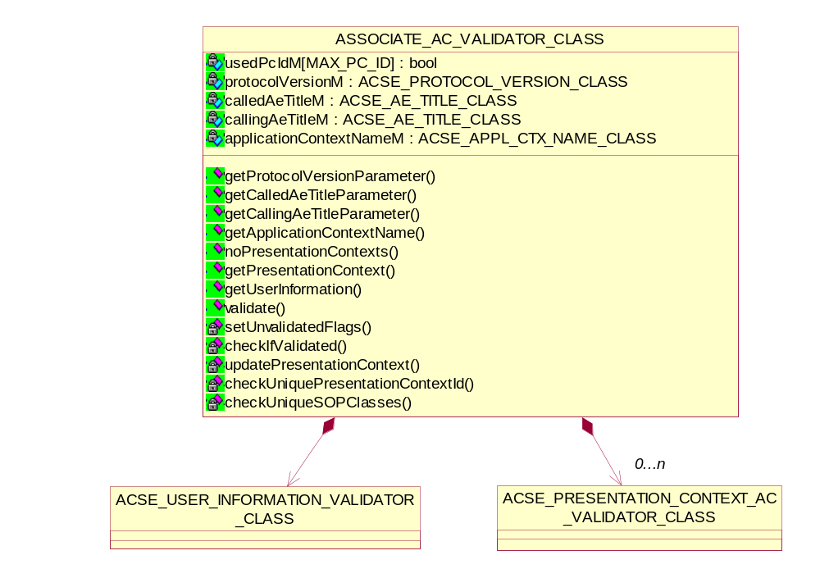
Figure 12 Diagram of Associate Acceptor Validator class

Getting the protocol version parameter
ACSE_PARAMETER_CLASS *getProtocolVersionParameter();

Getting the called AE title parameter
ACSE_PARAMETER_CLASS *getCalledAeTitleParameter();

Getting the calling AE title parameter
ACSE_PARAMETER_CLASS *getCallingAeTitleParameter();

Getting the Application context name parameter
ACSE_APPL_CTX_NAME_CLASS& getApplicationContextName();

Getting the nr of Presentation contexts
UINT noPresentationContexts();

Getting the Presentation context parameter
ACSE_PRESENTATION_CONTEXT_AC_VALIDATOR_CLASS& getPresentationContext(UINT);

Getting the User information parameter
ACSE_USER_INFORMATION_VALIDATOR_CLASS& getUserInformation();

Validating the Association request
bool validate(ASSOCIATE_AC_CLASS *srcAssocAc_ptr,
ASSOCIATE_AC_CLASS *refAssocAc_ptr,
ACSE_PROPERTIES_CLASS * acseProp_ptr);
Return value | Explanation
true | Validation of the Association request has been successful.
false | Validation of the Association request has been failed.

Checking all presentation contexts
bool checkIfValidated(ASSOCIATE_AC_CLASS*, ASSOCIATE_AC_CLASS*);
This method checks if all source and reference presentation contexts have been validated.

Updating the presentation context
void updatePresentationContext(PRESENTATION_CONTEXT_AC_CLASS*);
This method updates the matching presentation context.

Checking the uniqueness of Presentation context ids
bool checkUniquePresentationContextId();
This method checks the uniqueness of all presentation context ids.

Checking the uniqueness of SOP classes in presentation context ids
bool checkUniqueSOPClasses(void);
This method checks that the presentation context ids contain unique SOP classes with Transfer Syntax.

Association Reject Validation
This class ASSOCIATE_RJ_VALIDATOR_CLASS validates the A-ASSOCIATE reject and checks all the association reject parameters.
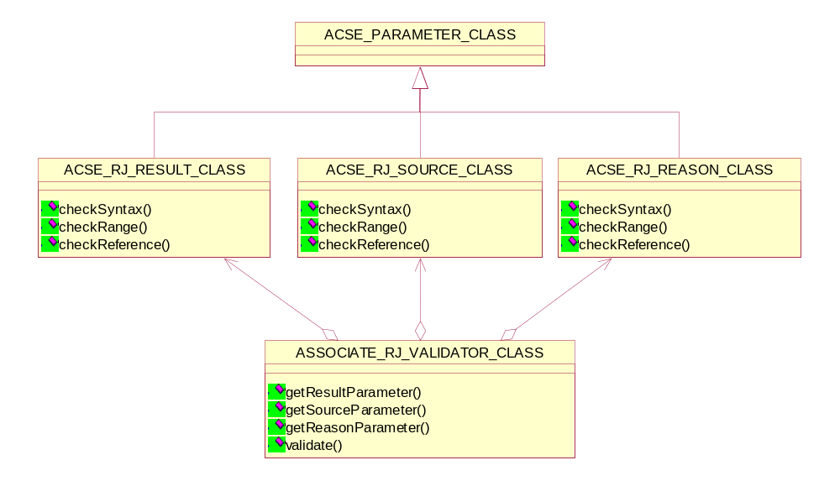
Figure 13 Diagram of Associate Reject Validator class

Getting the source parameter
ACSE_PARAMETER_CLASS *getSourceParameter();

Getting the reason parameter
ACSE_PARAMETER_CLASS *getReasonParameter();

Getting the result parameter
ACSE_PARAMETER_CLASS * getResultParameter ();

Validating the Association reject request
bool validate(ASSOCIATE_RJ_CLASS*, ASSOCIATE_RJ_CLASS*);
Return value | Explanation
true | Validation of the Association reject has been successful.
false | Validation of the Association reject has been failed.

ACSE_RJ_SOURCE_CLASS
This class indicates the initiating source of this association reject and derived from ACSE parameter class. This Source field shall contain an integer value encoded as an unsigned binary number.
One of the following values shall be used
1 - DICOM UL service-user
2 - DICOM UL service-provider (ACSE related function)
3 - DICOM UL service-provider (Presentation related function)

Checking the syntax of source parameter
bool checkSyntax();

Checking the range of source parameter
bool checkRange();
This method checks the range of source parameter value and the range should be in the fields defined above.

Checking the source parameter against reference value
bool checkReference(string);

ACSE_RJ_REASON_CLASS
This class indicates the reason of this association reject and derived from ACSE parameter class.
This field shall contain an integer value encoded as an unsigned binary number.
If the Source field has the value (1) “DICOM UL service-user, it shall take one of the following:
1 - no-reason-given
2 - application-context-name-not-supported
3 - calling-AE-title-not-recognized
4-6 - reserved
7 - called-AE-title-not-recognized
8-10 - reserved
If the Source field has the value (2) “DICOM UL service provided (ACSE related function),” it shall take one of the following:
1 - no-reason-given
2 - protocol-version-not-supported
If the Source field has the value (3) “DICOM UL service provided (Presentation related function),” it shall take one of the following:
0 - reserved
1 - temporary-congestion
2 - local-limit-exceeded
3-7 - reserved

Checking the syntax of reason parameter
bool checkSyntax();

Checking the range of reason parameter
bool checkRange();
This method checks the range of reason parameter value and the range should be in the fields defined above.

Checking the reason parameter against reference value
bool checkReference(string);

ACSE_RJ_RESULT_CLASS
This class indicates the result of this association reject and derived from ACSE parameter class.
This field shall contain an integer value encoded as an unsigned binary number.
It shall take one of the following:
1 - rejected-permanent
2 - rejected-transient

Checking the syntax of result parameter
bool checkSyntax();

Checking the range of result parameter
bool checkRange();
This method checks the range of result parameter value and the range should be in the fields defined above.

Checking the result parameter against reference value
bool checkReference(string);

ACSE Parameter class
This class is the Base class for all the association parameters.
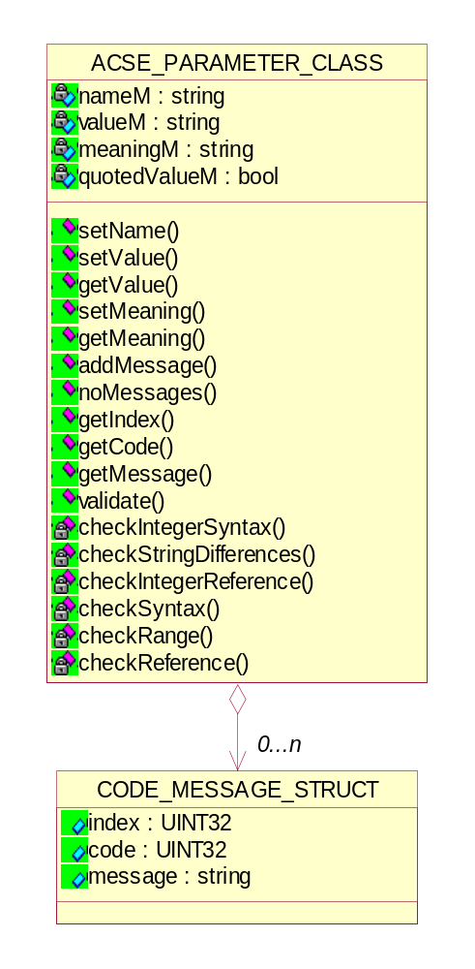
Figure 14 Diagram of ASCE Parameter class

Setting the name of the association parameter
void setName(const string);

Setting /Getting the value of the association parameter
void setValue(const string);
void setValue(char*, ...);
string getValue();

Getting the meaning of the association parameter
void setMeaning(const string);
string getMeaning();

Managing the messages
void addMessage(const string);
void addMessage(const int, const string);
void addMessage(char*, ...);
void addMessage(const int, char*, ...);
int noMessages();
string getMessage(const int);

Validate the association parameter syntax, range
bool validate(string, string);

Helper functions for checking the syntax and references
bool checkIntegerSyntax(int);
bool checkStringDifferences(char*, char*, int, bool, bool);
bool checkIntegerReference(string);

ACSE_AE_TITLE_CLASS
This class indicates the AE Title class for ACSE parameter validation.

Checking the syntax of AE title parameter
bool checkSyntax();

Checking the range of AE title parameter
bool checkRange();

Checking the AE title parameter against reference value
bool checkReference(string);

ACSE_APPL_CTX_NAME_CLASS
An application context explicitly defines the set of application service elements, related options and any other information necessary for the inter-working of Application Entities on an association.
Two Application Entities when establishing an association agree on an application context. The requestor of an association proposes an Application Context Name and the acceptor returns either the same or a different Application Context Name. The returned name specifies the application context to be used for this association. The offer of an alternate application context by the acceptor provides a mechanism for limited negotiation. If the requestor cannot operate in the acceptor's application context, it will issue an A-Abort request primitive. Such a negotiation will facilitate the introduction of future versions of the DICOM Application Entity.
This class indicates the Application context name and derived from ACSE parameter class.

Checking the range of Application context name parameter
bool checkRange();

ACSE_PROTOCOL_VERSION_CLASS
This class indicates the result of this association reject and derived from ACSE parameter class.
This field shall contain an integer value encoded as an unsigned binary number.
It shall take one of the following:
1 - rejected-permanent
2 - rejected-transient

Checking the syntax of Protocol version parameter
bool checkSyntax();

Checking the range of Protocol version parameter
bool checkRange();

Checking the Protocol version parameter against reference value
bool checkReference(string);

ACSE Async Operation Windows Validator Class
The Asynchronous Operations Window is used to negotiate the maximum number of outstanding operation or sub-operation requests (i.e. command requests) for each direction. The synchronous operations mode is the default mode and shall be support by all DICOM AEs. This negotiation is optional.
This class ACSE_ASYNCHRONOUS_OPERATION_WINDOW_VALIDATOR_CLASS validates the Asynchronous Operations Window parameters.
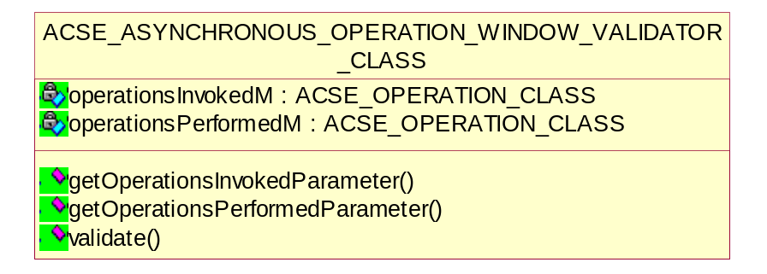
Figure 15 Diagram of Async Operation Windows Validator class

Getting the Operations Invoked parameter
ACSE_PARAMETER_CLASS * getOperationsInvokedParameter();

Getting the Operations performed parameter
ACSE_PARAMETER_CLASS * getOperationsPerformedParameter();

Validating the Asynchronous Operations Window
bool validate(UINT16, UINT16, USER_INFORMATION_CLASS*);
Return value | Explanation
true | Validation of the Asynchronous Operations Window has been successful.
false | Validation of the Asynchronous Operations Window has been failed.

ACSE_OPERATION_CLASS
This class indicates the asynchronous performed and invoked operations.

Checking the syntax of operation parameter
bool checkSyntax();

Checking the range of operation parameter
bool checkRange();
Default implementation, nothing to check.

Checking the operation parameter against reference value
bool checkReference(string);

ACSE Presentation Context Request Validator Class
A Presentation Context defines the presentation of the data on an Association. It provides a lower level of negotiation and one or more Presentation Contexts can be offered and accepted per Association.
A Presentation Context consists of three components, a Presentation Context ID, an Abstract Syntax Name, and a list of one or more Transfer Syntax Names.
Only one Abstract Syntax shall be offered per Presentation Context. However, multiple Transfer Syntaxes may be offered per Presentation Context, but only one shall be accepted.
For each SOP Class or Meta SOP Class a Presentation Context must be negotiated such that this Presentation Context supports the associated Abstract Syntax and a suitable Transfer Syntax. Presentation Contexts will be identified within the scope of a specific association by a Presentation Context ID.
This class represents the offered Presentation Context.

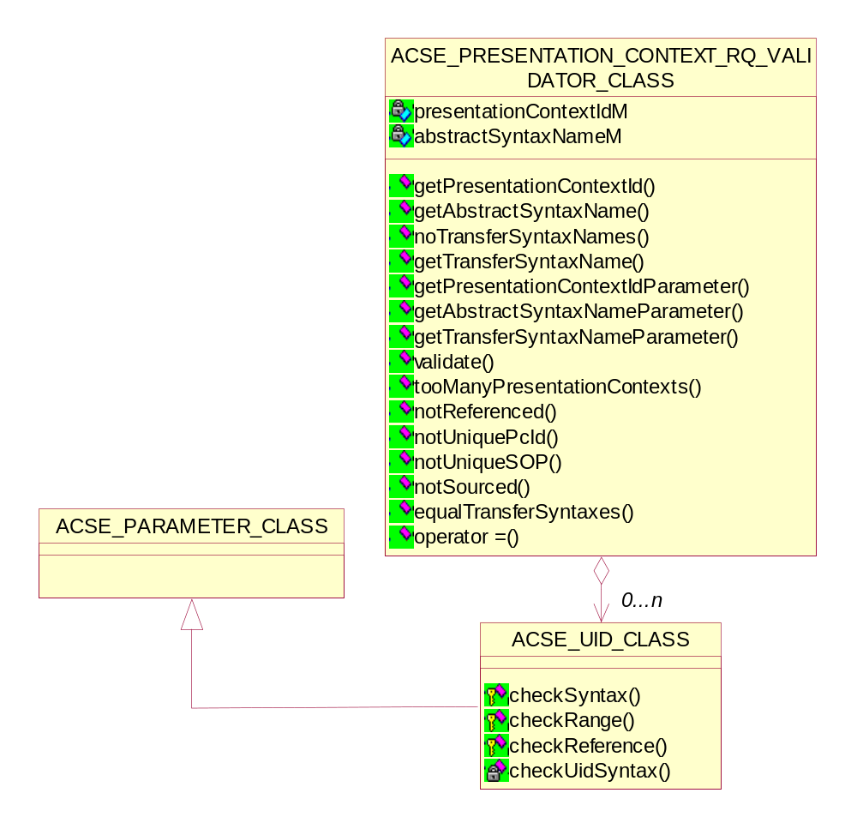
Figure 16 Diagram of Presentation Context Requestor Validator class

Getting the Presentation Context Id parameter
ACSE_PARAMETER_CLASS * getPresentationContextIdParameter();

Getting the Abstract Syntax name parameter
ACSE_PARAMETER_CLASS * getAbstractSyntaxNameParameter();

Getting the Transfer Syntax name parameter
ACSE_PARAMETER_CLASS * getTransferSyntaxNameParameter();

Getting the Presentation Context Id
string getPresentationContextId();

Getting the Abstract Syntax name
string getAbstractSyntaxName();

Getting the nr of Transfer Syntax
UINT noTransferSyntaxNames();

Getting the Transfer Syntax name
string getTransferSyntaxName(UINT);

Checking the Presentation Context uniqueness
void tooManyPresentationContexts();
void notReferenced();
void notUniquePcId();
void notUniqueSOP(string, string);
void notSourced(PRESENTATION_CONTEXT_RQ_CLASS*);

Checking the Transfer Syntaxes
bool equalTransferSyntaxes(ACSE_PRESENTATION_CONTEXT_RQ_VALIDATOR_CLASS&);

Validating the requested Presentation Context
bool validate(UINT16, UINT16, USER_INFORMATION_CLASS*);
Return value | Explanation
true | Validation of the requested Presentation Context has been successful.
false | Validation of the requested Presentation Context has been failed.

ACSE_UID_CLASS
This class indicates the UID. Unique Identifiers (UIDs) provide the capability to uniquely identify a wide variety of items. They guarantee uniqueness across multiple countries, sites, vendors and equipment. Different classes of objects, instance of objects and information entities can be distinguished from one another across the DICOM universe of discourse irrespective of any semantic context.
Each UID is composed of two parts, an <org root> and a <suffix>:
UID = <org root>.<suffix>
The <org root> portion of the UID uniquely identifies an organization, (i.e., manufacturer, research organization, NEMA, etc.), and is composed of a number of numeric components as defined by ISO 8824. The <suffix> portion of the UID is also composed of a number of numeric components, and shall be unique within the scope of the <org root>. This implies that the organization identified in the <org root> is responsible for guaranteeing <suffix> uniqueness by providing registration policies. These policies shall guarantee <suffix> uniqueness for all UID's created by that organization. Unlike the <org root>, which may be common for UID's in an organization, the <suffix> shall take different unique values between different UID's that identify different objects.
The <org root> "1.2.840.10008" is reserved for DICOM defined items (such as DICOM Transfer Syntaxes) and shall not be used for privately defined items (such as an Image Instance).

Checking the syntax of UID parameter
bool checkSyntax();

Checking the range of UID parameter
Virtual bool checkRange();
Default implementation, nothing to check.

Checking the UID parameter against reference value
bool checkReference(string);

Checking the UID syntax
bool checkUidSyntax(char*);

ACSE Presentation Context Acceptor Validator Class
This class represents the accepted Presentation Context.
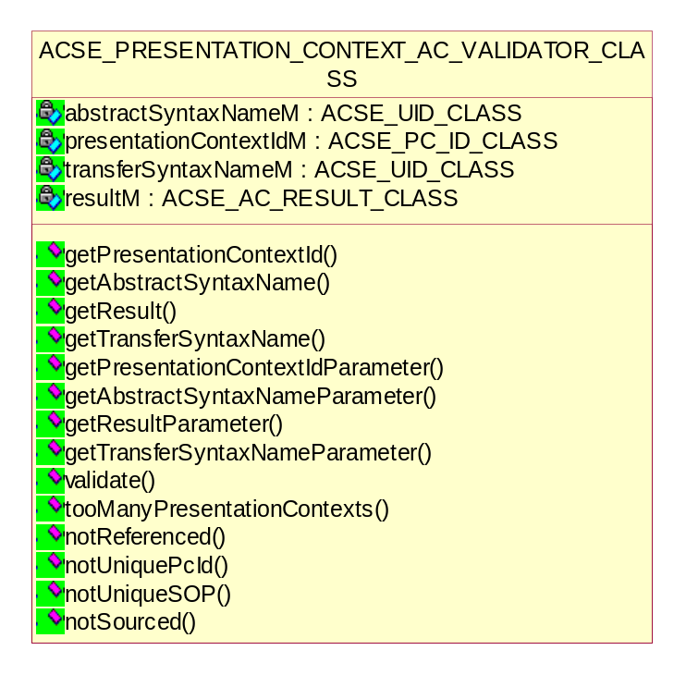
Figure 17 Diagram of Presentation Context Acceptor Validator class

Getting the Presentation Context Id parameter
ACSE_PARAMETER_CLASS * getPresentationContextIdParameter();

Getting the Abstract Syntax name parameter
ACSE_PARAMETER_CLASS * getAbstractSyntaxNameParameter();

Getting the Result parameter
ACSE_PARAMETER_CLASS *getResultParameter();

Getting the Transfer Syntax name parameter
ACSE_PARAMETER_CLASS * getTransferSyntaxNameParameter();

Getting the Presentation Context Id
string getPresentationContextId();

Getting the Abstract Syntax name
string getAbstractSyntaxName();

Getting the result of Presentation Context request
string getResult();

Getting the Transfer Syntax name
string getTransferSyntaxName(UINT);

Checking the Presentation Context uniqueness
void tooManyPresentationContexts();
void notReferenced();
void notUniquePcId();
void notUniqueSOP(string, string);
void notSourced(PRESENTATION_CONTEXT_RQ_CLASS*);

Validating the accepted Presentation Context
bool validate(PRESENTATION_CONTEXT_AC_CLASS*, ASSOCIATE_AC_CLASS*);
Return value | Explanation
true | Validation of the accepted Presentation Context has been successful.
false | Validation of the accepted Presentation Context has been failed.

ACSE User Information Validator Class
When peer DICOM AEs negotiate, at association establishment a number of features related to the Dimse protocol by using the ACSE User Information Item of the A-ASSOCIATE request. The following are the features in User Information:
- Maximum Length
- Implementation Class UID
- Implementation Version Name
- Asynchronous Operations Window
- SCP SCU Role Selections
- SOP Class Extended Negotiations

Note: Asynchronous Operations Window class already explained in sec .
- 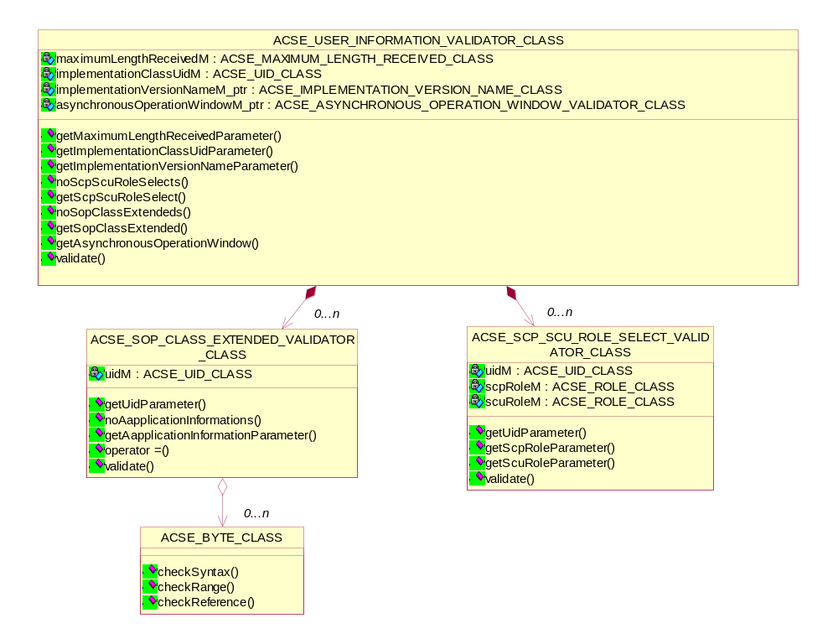
Figure 18 Diagram of User Information Validator class

ACSE_SCP_SCU_ROLE_SELECT_VALIDATOR_CLASS
The SCP/SCU role selection negotiation allows peer AEs to negotiate the roles in which they will serve for each SOP Class or Meta SOP Class supported on the Association. This negotiation is optional.
This class indicates the SCP/SCU role selection and derived from ACSE parameter class.

Getting the UID parameter
ACSE_PARAMETER_CLASS * getUidParameter();

Getting the SCP role parameter
ACSE_PARAMETER_CLASS * getScpRoleParameter();

Getting the SCU role parameter
ACSE_PARAMETER_CLASS * getScuRoleParameter();

Validating the SCP/SCU role selection parameter
bool validate(SCP_SCU_ROLE_SELECT_CLASS*, USER_INFORMATION_CLASS*);
Return value | Explanation
true | Validation of the SCP/SCU role selection has been successful.
false | Validation of the SCP/SCU role selection has been failed.

ACSE_SOP_CLASS_EXTENDED_VALIDATOR_CLASS
The SOP Class Extended Negotiation allows, at Association establishment, peer DICOM AEs to exchange application information defined by specific Service Class specifications.
This is an optional feature that various Service Classes may or may not choose to support.
This class indicates the SOP Class Extended Negotiation and derived from ACSE parameter class.

Getting the UID parameter
ACSE_PARAMETER_CLASS * getUidParameter();

Getting the number of Application Information
UINT noAapplicationInformations();

Getting the Application Information
ACSE_PARAMETER_CLASS * getAapplicationInformationParameter(UINT);

Validating the SOP Class Extended parameter
bool validate(SOP_CLASS_EXTENDED_CLASS*, USER_INFORMATION_CLASS*);
Return value | Explanation
true | Validation of the SOP Class Extended has been successful.
false | Validation of the SOP Class Extended has been failed.

ACSE_IMPLEMENTATION_VERSION_NAME_CLASS
The implementation identification notification allows implementations of communicating AEs to identify each other at Association establishment time.
It is intended to provide respective (each network node knows the other's implementation identity) and non-ambiguous identification in the event of communication problems encountered between two nodes.
This negotiation is required.
Implementation identification relies on two pieces of information:
- Implementation Class UID (required)
- Implementation Version Name (optional)
Only one Implementation Version Name Sub-Item shall be present in the User Data Item of the A-ASSOCIATE-RQ.
Only one Implementation Version Name Sub-Item shall be present in the User Data Item of the A-ASSOCIATE-AC.
This class indicates the Implementation Version Name and derived from ACSE parameter class.

Checking the syntax of Protocol version parameter
bool checkSyntax();

Checking the range of Protocol version parameter
bool checkRange();
Default implementation, nothing to check.

Checking the Protocol version parameter against reference value
bool checkReference(string);

ACSE_MAXIMUM_LENGTH_RECEIVED_CLASS
The Maximum Length notification allows communicating AEs to limit the
size of the data for each P-DATA indication.
Each DICOM AE defines the maximum PDU size it can receive on this Association.
Therefore, different maximum lengths can be specified for each direction of data flow on an Association.
This class indicates the Maximum Length and derived from ACSE parameter class.

Checking the syntax of Maximum Length parameter
bool checkSyntax();

Checking the range of Maximum Length parameter
bool checkRange();

Checking the Maximum Length parameter against reference value
bool checkReference(string);

Media validation
The purpose of Media validation is to allow the interchange of various types of medical images and related information on a broad range of physical storage media.
Media validation entails validating media files and described in DICOM part 10 & 11. This includes validating the DICOM media file and DICOMDIR file.
There are basically two types of Media Validation Usage:
- Readers
Media readers are validated by creating a CD with test cases. If the CD is read correctly the reader is validated. Creation of the CD can be done with the aid of DVT, which supports writing a DICOMDIR from a (set of) script(s).
- Writers
Media writers can be validated with DVT. A CD is validated by validating the DICOMDIR with a specialized validation algorithm.

The specialized media validation takes the following into account:
- Record validation
For each record the following is checked:
- Check defined/referenced uids
For each attribute that defines an uid (attributes with VR UI) is checked whether the uid is unique and if the uid is referenced. For example a record may specify the sop class uid of the sop class in the file. Then it is checked whether the sop class uid in the file actually corresponds to the sop class uid specified in the record.
- Validation of the referenced file
If a file is referenced it is checked whether this file exists and the file is validated like any object.
- Comparison of attributes in the record and in the file
A directory record may contain attributes from the object which is specified in the referenced file. For each of these attributes is checked whether they are present in the file and if so the attributes are compared.

- Validation of directory record links
Each directory record has references to other records on the same level or to another level in the directory hierarchy, via the so-called 'offset attributes'. This directory chain is validated by comparing the specified offsets in the records with the offsets computed for the records (items).

- Check un-referenced records and uids
After the previously described validation steps have been performed a last check for any unreferenced records and\or uids is performed.

Description of Media Validation classes
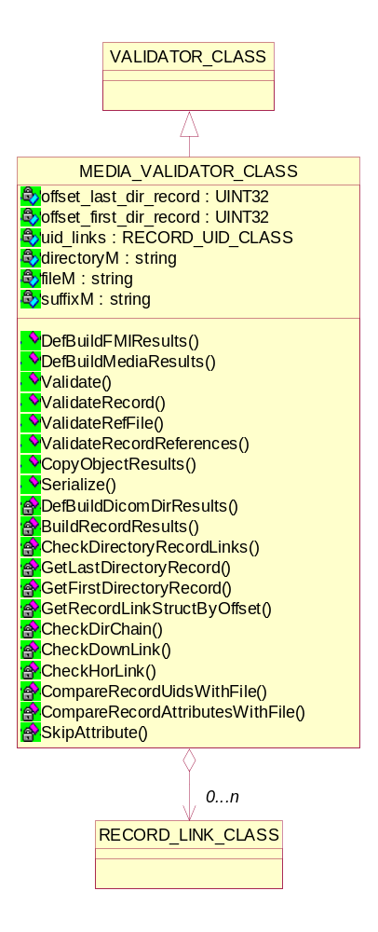
Figure 19 Diagram of Media Validator class

DefBuildFMIResults
The File Meta Information includes identifying information on the encapsulated Data Set. This header consists of a 128 byte File Preamble, followed by a 4 byte DICOM prefix, followed by the File Meta Elements as specified in DICOM part-10. This header shall be present in every DICOM file.

bool DefBuildFMIResults(FILE_DATASET_CLASS * file_dataset,
AE_SESSION_CLASS * ae_session);

Argument | Explanation
file_dataset | A pointer to the file dataset class.
ae_session | A pointer to the AE session class.
This function builds the definition media results structure. It gets and validates the file meta information and dataset for the SOP-Dimse combination from the file dataset.

DefBuildMediaResults
bool DefBuildMediaResults(FILE_DATASET_CLASS * file_dataset,
AE_SESSION_CLASS * ae_session);

Argument | Explanation
file_dataset | A pointer to the file dataset class.
ae_session | A pointer to the AE session class.
This function builds the definition File Meta Information results structure. It gets and validates the file meta information from the file dataset. This function calls DefBuildModuleResults function for looping through all the modules in the definition object. For each module a check is done to see if the module needs to be added to the results object. The check depends on the condition associated with the module. There are three possibilities: Mandatory, User or Conditional.

DefBuildDicomDirResults
bool DefBuildDicomDirResults(
DCM_DIR_DATASET_CLASS * dicomdir_dataset,
MEDIA_FILE_HEADER_CLASS * file_meta_info,
AE_SESSION_CLASS * ae_session,
DEF_ATTRIBUTE_GROUP_CLASS ** record);

Argument | Explanation
dicomdir_dataset | A pointer to DICOMDIR dataset object.
file_meta_info | A pointer to Media File Header object.
ae_session | A pointer to the AE session class.
record | A pointer to DICOM attribute group object.
This function builds the definition DICOMDIR results structure. This function calls DefBuildModuleResults function for looping through all the modules in the definition object of the DICOMDIR.

BuildRecordResults
void BuildRecordResults(DCM_ATTRIBUTE_GROUP_CLASS * record,
VAL_ATTRIBUTE_GROUP_CLASS * val_ag_results
RECORD_LINK_CLASS * record_link);

Argument | Explanation
record | A pointer to DICOM attribute group object.
val_ag_results | A pointer to Validation attribute group object.
record_link | A pointer to record link object.
This function builds the record results structure. This function calls BuildValueResults & BuildSQResults function for looping through all the attributes/items in the record.

Validating the File Dataset
Each File shall contain a single Data Set representing a single SOP Instance related to a single SOP Class (and corresponding IOD).
The Transfer Syntax used to encode the Data Set shall be the one identified by the Transfer Syntax UID of the DICOM File Meta Information.

bool Validate(FILE_DATASET_CLASS * file_dataset,
DCM_DATASET_CLASS * reference_dataset,
RECORD_UID_CLASS * uid_links,
VALIDATION_CONTROL_FLAG_ENUM validationFlag,
BASE_SERIALIZER * serializer_ptr,
AE_SESSION_CLASS * ae_session);

Argument | Explanation
file_dataset | A pointer to the file dataset class.
reference_dataset | A pointer to the DICOM dataset object.
uid_links | A pointer to the Record UID object.
validationFlag | A flag which provides validation options
serializer_ptr | A pointer to serialization object for serializing results.
ae_session | A pointer to the AE session class.
This function validates a media dataset object. The Validation is done in two steps - build results and validates the results.

Validating the DICOMDIR
bool Validate(DCM_DIR_DATASET_CLASS * dicomdir_dataset,
DCM_DATASET_CLASS * reference_dataset,
MEDIA_FILE_HEADER_CLASS * file_meta_info,
VALIDATION_CONTROL_FLAG_ENUM validationFlag,
AE_SESSION_CLASS * ae_session,
DEF_ATTRIBUTE_GROUP_CLASS ** record);

Argument | Explanation
dicomdir_dataset | A pointer to DICOMDIR dataset object.
reference_dataset | A pointer to DICOM dataset object.
file_meta_info | A pointer to Media File Header object.
validationFlag | A flag which provides validation options
ae_session | A pointer to the AE session class.
record | A pointer to DICOM attribute group object
This function validates the DICOMDIR dataset object. This function calls the helper function DefBuildDicomDirResults & BuildModuleResults.

Validating the Record
The Basic Directory IOD organization is based on a hierarchy of Directory Entities. At the origin of this inverted tree is a root Directory Entity. Each Directory Entity includes one or more Directory Records which in turn, may each reference a lower level Directory Entity.
Directory Records serve to reference objects stored in the Files of the File-set.
Each Directory Record, irrespective of the Directory Entity it is included in, contains four types of information:
- A reference to a lower level Directory Entity or Referenced Directory Entity. This reference may be absent if such a lower level Directory Entity does not exist for an instance of a directory record;
- A reference to a File of the File-set in which is stored a "Referenced Object" (formally called in DICOM a Referenced SOP Instance). This reference may be absent if no File is referenced. Files may be referenced either directly by their File ID or indirectly through a Multi-Referenced File Directory Record. The latter case allows the same File to be referenced by several Directory Records;
- A set of "selection keys," specific to a Referenced Object, which will allow its selection among all the records included in a given Directory Entity;
- A mechanism to chain the various Directory Records which belong to the same Directory Entity.

bool ValidateRecord (DCM_ITEM_CLASS * record,
DCM_DATASET_CLASS * reference_record,
DEF_ATTRIBUTE_GROUP_CLASS * record_definition,
VALIDATION_CONTROL_FLAG_ENUM validationFlag,
AE_SESSION_CLASS * ae_session,
LOG_CLASS * logger_ptr,
BASE_SERIALIZER * serializer_ptr,
UINT32 record_index,
STORAGE_MODE_ENUM storage_mode);

Argument | Explanation
record | A pointer to DICOM item object.
reference_record | A pointer to the DICOM dataset object.
record_definition | A pointer to the definition attribute group object.
validationFlag | A flag, which provides validation options.
ae_session | A pointer to the AE session object.
logger_ptr | A pointer to logging object.
serializer_ptr | A pointer to serialization object for serializing results.
record_index | Record index
storage_mode | Type of storage represented by enum
This function loops over all items that are in reality directory records. If there is a referenced file and this file should be validated then
  - Validate that file.
  - Extract instance UID from that file.
  - Extract the instance UID from the record.
Check DICOMDIR hierarchy. Each record must be referenced only once.

Validating the reference file
Any Directory Record may contain a "referenced object" or Referenced SOP Instance. All referenced Files shall be with the File-set to which the Directory belongs. Any File within the File-set (to which the Directory belongs) shall be referenced by at most one Directory Record. To reference a single File by more than one Directory Record, a special Directory Record of Directory Record Type Multiple Referred Directory Record (MRDR) is used.

bool ValidateRefFile(FILE_DATASET_CLASS * file_dataset,
RECORD_RESULTS_CLASS * record,
DCM_DATASET_CLASS * reference_dataset,
VALIDATION_CONTROL_FLAG_ENUM validationFlag,
AE_SESSION_CLASS * ae_session);

Argument | Explanation
file_dataset | A pointer to the file dataset object.
record | A pointer to record results object
reference_dataset | A pointer to the DICOM dataset object.
validationFlag | A flag which provides validation options
ae_session | A pointer to the AE session class.
This function validates the referred file by updating the results structure with the reference values. This function calls the helper function DefBuildFMIResults & BuildModuleResults.

Validating the record references
bool ValidateRecordReferences(void);
This method validates the:
- Directory record chain,
- Record references.

Copying of the object results
void CopyObjectResults(
VAL_OBJECT_RESULTS_CLASS ** reference_file_results);
This method copies the object results and loses owner ship of the object results.

Serializing the validation results
void Serialize(BASE_SERIALIZER * serializer_ptr);
This method serializes the validation results.

Getting the directory record
RECORD_LINK_CLASS * GetLastDirectoryRecord (void);
RECORD_LINK_CLASS * GetFirstDirectoryRecord(void);

Checking the directory record links
bool CheckDirectoryRecordLinks(void);

Getting the record link by offset
RECORD_LINK_CLASS * GetRecordLinkStructByOffset (UINT32 offset);

Checking the Directory record chain
void CheckDirChain(RECORD_LINK_CLASS * record_link,
UINT parent_record_type_idx);
This method checks the complete directory record chain. The first record must be a valid record, so the entire chain can be checked.

Checking the vertical (down) & Horizontal record links
void CheckDownLink(RECORD_LINK_CLASS * record_link,
UINT parent_record_type_idx);
void CheckHorLink (RECORD_LINK_CLASS * record_link,
UINT parent_record_type_idx);

Comparing the record UIDs with referenced file
void CompareRecordUidsWithFile(RECORD_RESULTS_CLASS * record);
This method compares the record UIDs with those in the referenced file.

Comparing the record attributes with referenced file
void CompareRecordAttributesWithFile(
RECORD_RESULTS_CLASS * record);
This method compares the record attributes with those in the referenced file.

Record Results Class
During Media validation, a record results structure will be created on the same line to other validators. Part of this results structure is the (part of) contents of a definition object. This definition object is a service class and a SOP class. This object contains all possible attributes that can be expected in an incoming DICOM message.

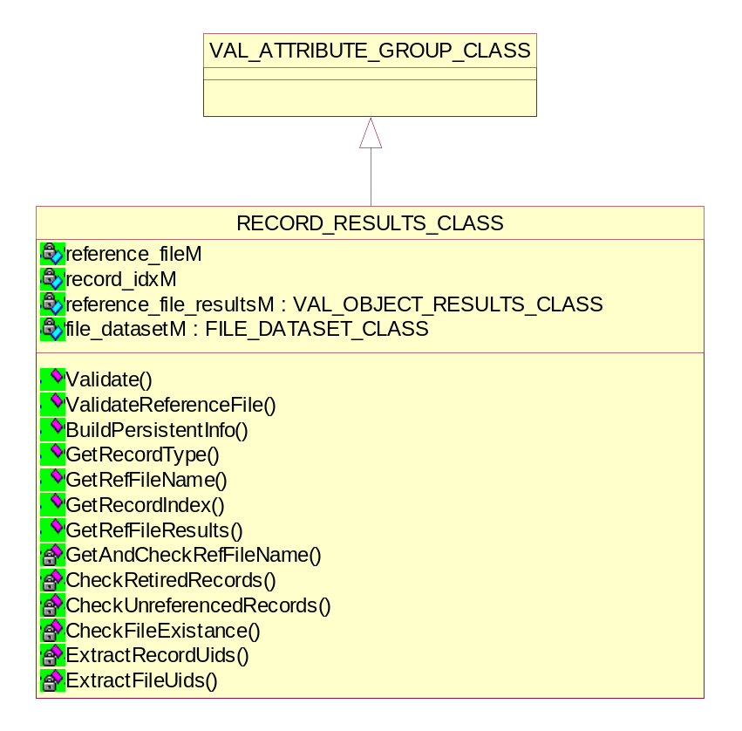
Figure 20 Diagram of Record Results class

Validating the directory record
void Validate (string root_dir_location);
This function performs validation on the record. It extracts the reference filename from the filename attribute in the record.

Checking the Maximum Length parameter against reference value
VAL_OBJECT_RESULTS_CLASS * GetRefFileResults(void);

Validating the reference file linked with a record
bool ValidateReferenceFile(RECORD_UID_CLASS * uid_links,
VALIDATION_CONTROL_FLAG_ENUM validationFlag,
AE_SESSION_CLASS * ae_session,
LOG_CLASS * logger_ptr,
BASE_SERIALIZER * serializer_ptr,
STORAGE_MODE_ENUM storage_mode);
This function creates a validator to validate the reference file associated with this record.

Building the persistent information about record UIDs
void BuildPersistentInfo(RECORD_UID_CLASS * uid_links);
This function extracts record UIDs from the DICOMDIR record.

Getting the referenced file name
string GetRefFileName(void);

Getting the record index
UINT32 GetRecordIndex(void);

Getting the record type
DICOMDIR_RECORD_TYPE_ENUM GetRecordType(void);
This function returns the record type of the DICOMDIR record.

Extracting the UIDs
void ExtractRecordUids(DCM_ATTRIBUTE_GROUP_CLASS * dcm_record,
RECORD_UID_CLASS * uid_links);
bool ExtractFileUids(FILE_DATASET_CLASS * file_dataset,
RECORD_UID_CLASS * uid_links);

Checking for the un-referenced records
bool CheckUnreferencedRecords(void);

Checking for the retired records
bool CheckRetiredRecords(void);
This function checks if the record is retired. If ‘true’, a new validation message is added to the record.

Checking for the reference file existence on the media
bool CheckFileExistance(string filename);

Record UID Class
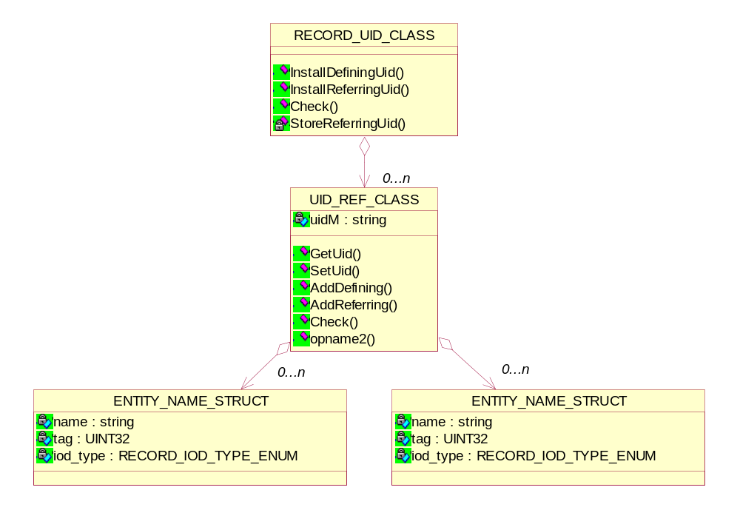
Figure 21 Diagram of Record UID class

Installation of all defining instance UID/identifier
bool InstallDefiningUid(DCM_ATTRIBUTE_GROUP_CLASS * record,
UID_DEFINING_CLASS * uid_def);
This method installs all defining instance UID/identifier combinations in case it's not installed already.

Installation of all referring instance UID/identifier
bool InstallReferringUid(DCM_ATTRIBUTE_GROUP_CLASS * record,
UID_REFERRING_CLASS * uid_ref);
This method installs all referring instance UID/identifier combinations in case it's not installed already.

Checking the log messages
void Check(LOG_MESSAGE_CLASS * messages);

Storing of all referring instance UID/identifier
void StoreReferringUid(string uid,
UID_REFERENCE_STRUCT * uid_ref,
string identifier);

UID Ref Class

Getting/Setting the UID of reference object
string GetUid(void);
void SetUid(string uid);

Adding a new defining entity to the UID reference object
void AddDefining(ENTITY_NAME_STRUCT * entity);

Adding a new referring entity to the UID reference object
void AddReffering(ENTITY_NAME_STRUCT * entity);

Checking the log messages
void Check(LOG_MESSAGE_CLASS * messages);

Record Link Class
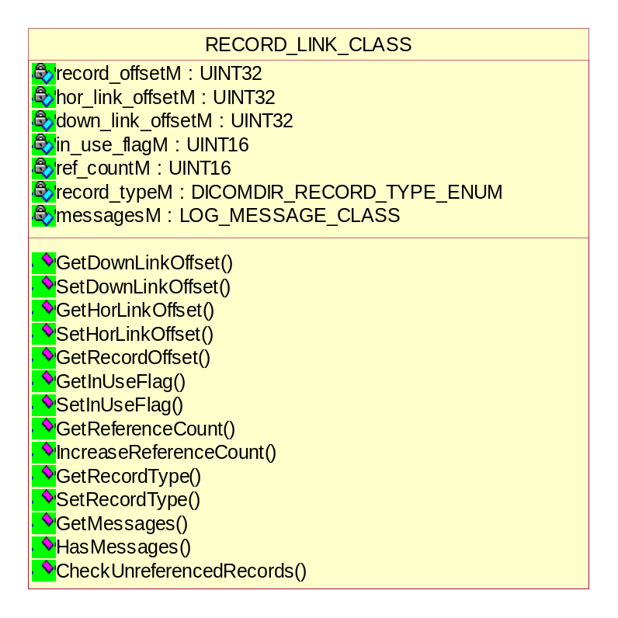
Figure 22 Diagram of Record Link class

Getting/Setting the down link offset
UINT32 GetDownLinkOffset(void);
void SetDownLinkOffset(UINT32 offset);

Getting/Setting the horizontal link offset
UINT32 GetHorLinkOffset(void);
void SetHorLinkOffset(UINT32 offset);

Getting the record offset
UINT32 GetRecordOffset(void);

Getting/Setting the in-use flag for a record
UINT16 GetInUseFlag(void);
void SetInUseFlag(UINT16 in_use_flag);

Managing the reference count for a record
UINT16 GetReferenceCount (void);
void IncreaseReferenceCount (void);

Getting/Setting the record type
DICOMDIR_RECORD_TYPE_ENUM GetRecordType(void);
void SetRecordType(DICOMDIR_RECORD_TYPE_ENUM record_type);

Checking the Un-referenced record
bool CheckUnreferencedRecords(void);

Record Type Class
Defines a specialized type of Directory Record by reference to its position in the Media Storage Directory Information Model. Required if the Directory Record Sequence is not zero length. The different types of records as given below:

PATIENT STUDY SERIES IMAGE OVERLAY MODALITY LUT VOI LUT CURVE TOPIC
VISIT RESULTS INTERPRETATION STUDY COMPONENT STORED PRINT RT DOSE RT STRUCTURE SET RT PLAN RT TREAT RECORD PRESENTATION WAVEFORM SR DOCUMENT KEY OBJECT DOC SPECTROSCOPY RAW DATA REGISTRATION FIDUCIAL

The relationship between above records can be referred from DICOM standard part3 Annex F.

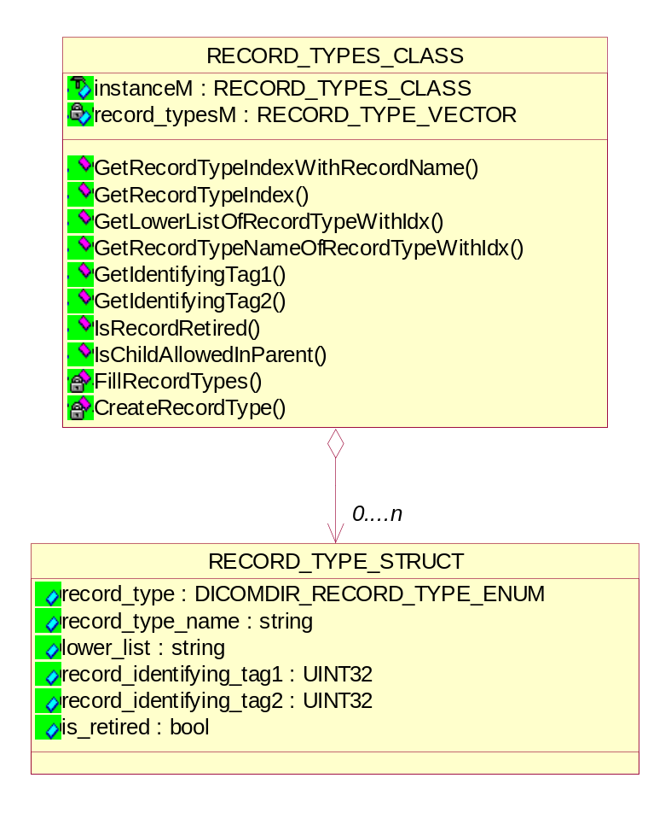
Figure 23 Diagram of Record Type class

Getting the record type from record name
DICOMDIR_RECORD_TYPE_ENUM GetRecordTypeIndexWithRecordName (BASE_VALUE_CLASS * value);
This function returns the record type with the given record name.

Getting the record type index
UINT GetRecordTypeIndex (DICOMDIR_RECORD_TYPE_ENUM record_type);
This function returns the record type of the DICOMDIR record.

Getting lower list of record type with the given index
string GetLowerListOfRecordTypeWithIdx (UINT index);

Getting record type name with the given index
string GetRecordTypeNameOfRecordTypeWithIdx (UINT index);

Getting the record identifying tags
UINT32 GetIdentifyingTag1 (UINT index);
UINT32 GetIdentifyingTag2 (UINT index);

Checking if record is retired
bool IsRecordRetired (UINT index);

Checking the child record status
bool IsChildAllowedInParent (UINT parent_idx, UINT child_idx);
This function returns ‘true’ when the record type with index allows having the record type with index as a child record type.

Creating the all supported record types
void FillRecordTypes(void);
This function creates the array of all supported record types within DVT.

Creating the one record type
RECORD_TYPE_STRUCT * CreateRecordType(
DICOMDIR_RECORD_TYPE_ENUM record_type,
string record_type_name,
string lower_list,
UINT32 record_identifying_tag1,
UINT32 record_identifying_tag2,
bool is_retired);
This function creates one record type within DVT.

Query/Retrieve Validation
For query retrieve, there are two deviations from the standard validation are taken care of:
- Date/Time ranges
For query retrieve attributes with VR DA or TM, range specifications are allowed. This is taken care of in the overloaded checkDAValue and checkTMValue functions of Attribute Group library.
- Check against request object
A check against the request object is available. In this check is verified whether attributes in the response dataset of a find were actually present in the find request dataset.

QR Validator Class

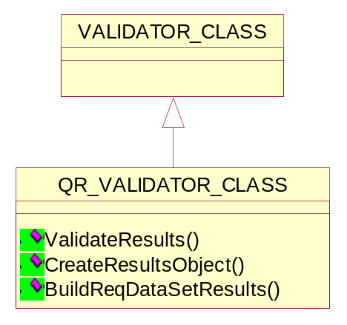
Figure 24 Diagram of QR Validator class

Validate the build results object
void ValidateResults(VALIDATION_CONTROL_FLAG_ENUM validationFlag);
This function validates the data present in the object results structure according to given validation options.

Create the results object
bool CreateResultsObject(void);
This function returns ‘true’ when the results object created successfully.

Build the results object with requested dataset
void BuildReqDataSetResults(DCM_DATASET_CLASS * dataset);

QR Object Results Class
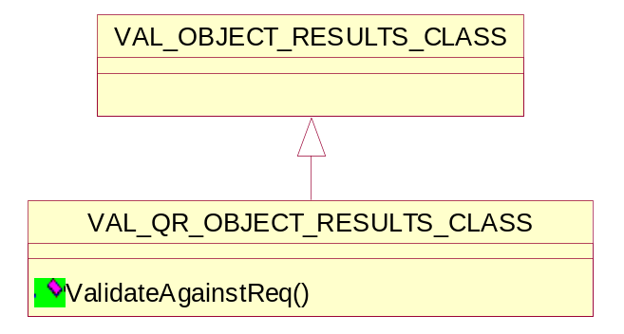
Figure 25 Diagram of QR Object results class

Checking if record is retired
DVT_STATUS ValidateAgainstReq(UINT32 flags);
This function validates the attributes from the requested object against the incoming data stream.
Return value | Explanation
MSG_OK | Validating against the incoming object has been successful.
MSG_ERROR | An error has occurred when validating against the incoming object.

Validation QR Attribute Class

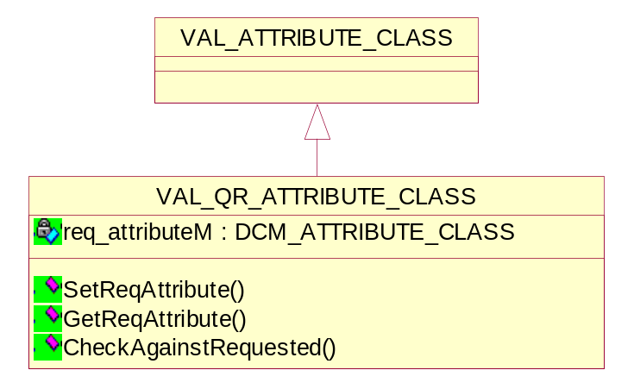
Figure 26 Diagram of Validation QR attribute class

Setting the requested attribute
void SetReqAttribute(DCM_ATTRIBUTE_CLASS * req_attr);

Getting the requested attribute
DCM_ATTRIBUTE_CLASS * GetReqAttribute(void);

Checking against the requested attribute
void CheckAgainstRequested(void);

